Evolve from Monolithic to Event-driven Microservices Architecture with designing High Scalable and High Available system using all type of Databases, Cache, API Gateway, Inter-service communications, Event-driven, Transactions, Containers and orchestrations, Monitoring

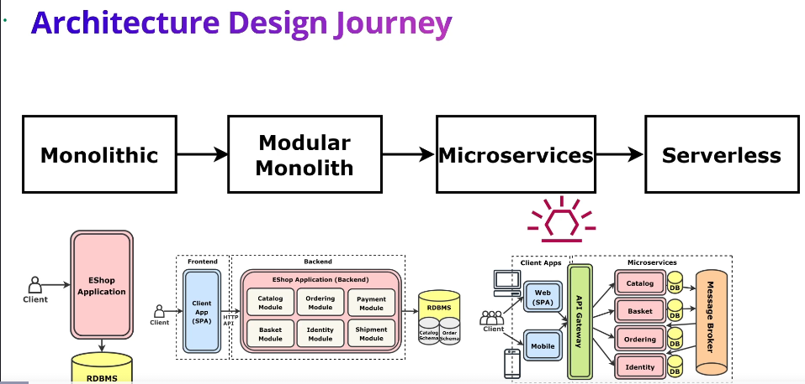

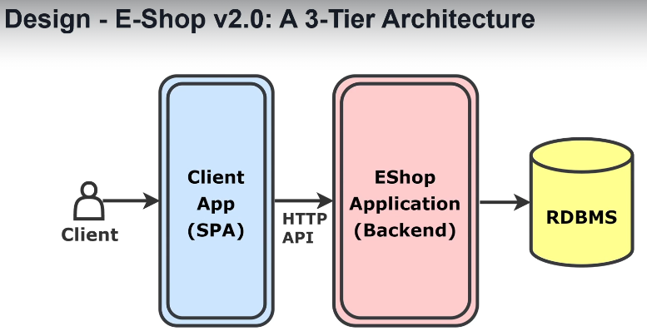

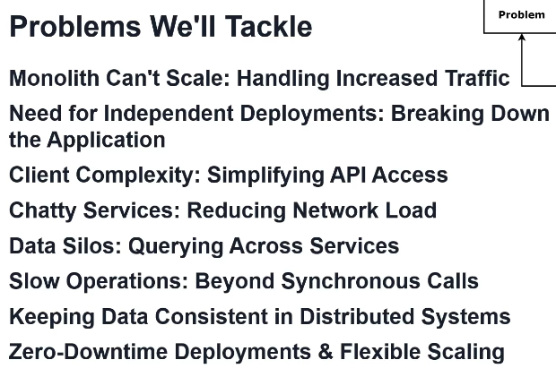

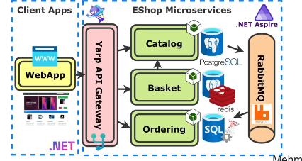

Radicu EShop, pocevsi od Monolith, preko Modular Monolithic, Microservices i na kraju Serverless arhitekture. U svakoj arhitekturi bice problema koji ce naterati na upgrade u vecu arhitekturu.

**Monolithic architecture:**

Design principles:

1. DRY (Don’t Repeat Yourself) - avoid duplicated code
2. KISS (Keep It Simple and Stupid) – simplicity is a goal
3. YAGNI (You Aint Gonna Need It) – don’t implement functionality based on future speculations. Focus on current requirements.

Prvi korak svakog arhitekte je da spozna:

1. Functional requirements – list products, view products details, add products to shopping basket….
2. Non-functional requirements – availability, small number of concurrent users, simplicity
3. Constraints (time, cost, team)
4. Learned architectures – za sada Monolithic
5. Patterns & principles – za sada DRY, KISS, YAGNI

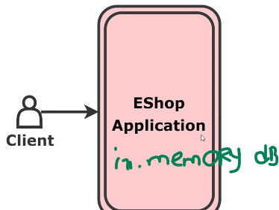

Koristim in-memory DB i FE je u istom folderu kao BE, jer koristim MVC. Ako sam stavio neke products u shopping cart (basket), to se sacuvalo u BE, a server (koji odrzava BE) se ugasio, kada se povrati, shopping cart je prazan. Ovo me tera da koristim normalnu bazu (SQL Server, Mongo, Postgres…) koja nije in-memory, jer ako shopping cart upisem u nju, i BE ako kresuje, podaci su I dalje u bazi. Preferiram Relational DB jer EShop je u pitanju.

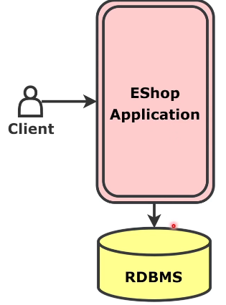

Sledeci problem je FE i BE sto nisu razdvojeni i tu koristim 3-Tier arhitekturu.

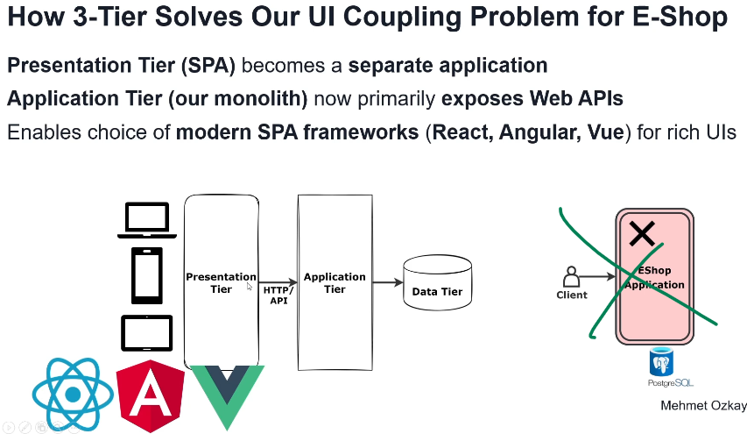

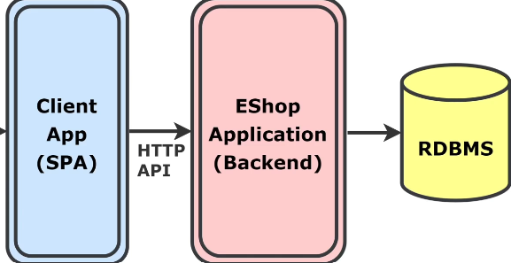

Sada raste app, new features, codebase is increasing I sve postaje ogroman kod u jednom project folderu u VS.

**Modular monolith:**

Modular monolith je I dalje jedan project u VS kao I Monolith, samo nije sve u istom fajlu, vec svaki service ima svoja fajl itd.

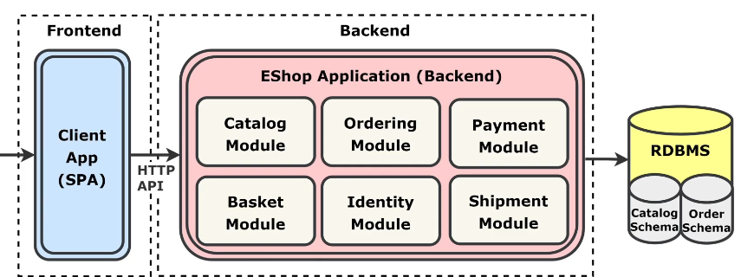

Svaki module ima svoju tabelu u bazi.

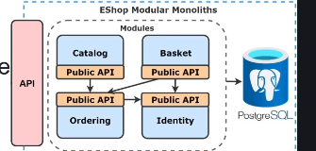

Koristim Separate Schema DB approach za svaki module u istoj bazi posebna schema.

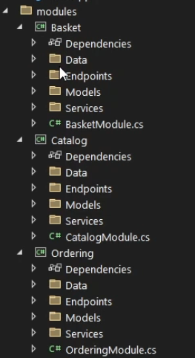

Svaki module je Projekat za sebe ali svi koriste istu bazu.

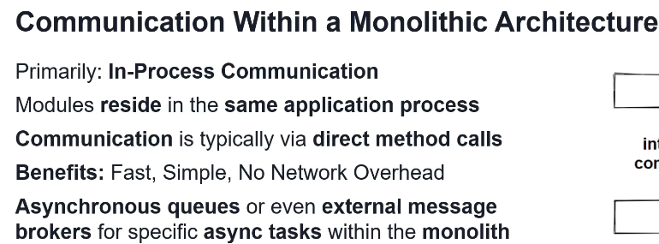

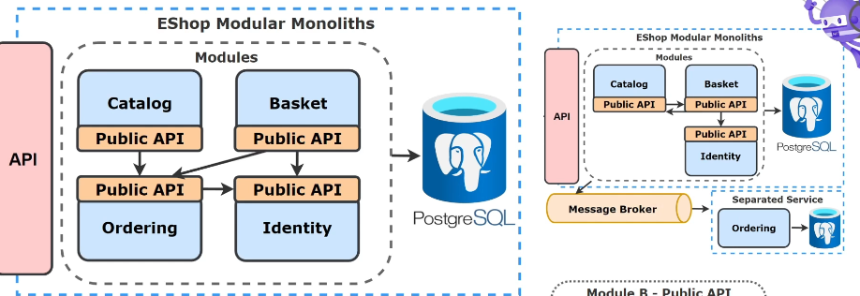

Ako EShop postane popularan, imacu mnogo korisnika na FE koji ce da klikcu da nesto kupe i to ce da optereti BE tacnije prvo ce da optereti bazu (i BE, ali o tome malo kasnije), jer svi modules koriste istu bazu. Cesto pozivanje baze je veoma sporo i skupo. Ovaj problem cu resiti with Cachin (distributed (Redis) ili in-memory, ali bolje Redis naravno jer ako BE pukne da podaci ostanu zapisani kad se BE resetuje). U Cache se stavljaju podacima kojima se cesto pristupa, jer ako klijent zazeli nesto, BE pogleda prvo u Cache ima li ga, ako nema, onda ga iz DB doda u Cache (za naredni put da ima), pa ga posalje clientu.

Iako je Cache resio DB probleme sto se tice brzine citanja podataka, I dalje imam single instance of BE, pa ce gomila user requests (gomila korisnika kupuje na sajtu) da optereti BE. Ovo se resave with Scalability koja moze biti Vertical ili Horizontal.

**Scalability – Vertical & Horizontal:**Koristi se kada saobracaj prebukira single BE instance.

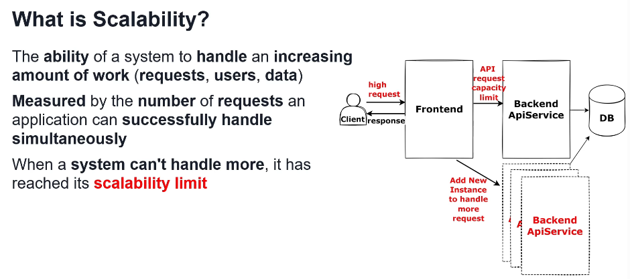

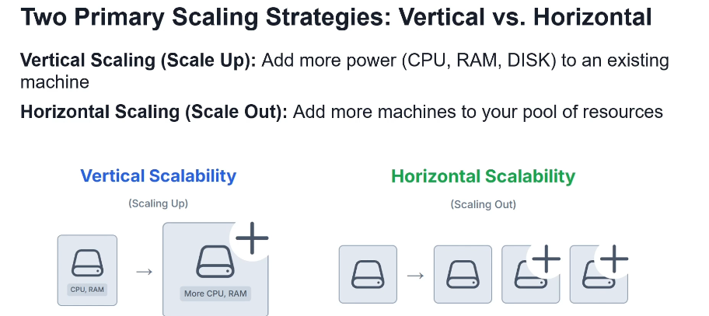

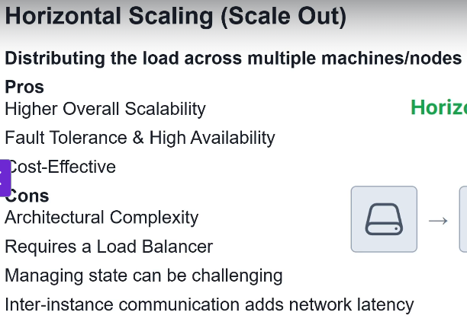

Load Balancer je traffic manager koji kontrolise saobracaj from FE I rasporedjuje na koju BE instancu ce da ide (jer uradio sam horizontal scaling koji se najcesce radi tako da sada nemam samo 1 BE, vec nekoliko njih istih naravno). On prati koliko je koja isntanca opterecena i na osnovu toga prosledjuje joj saobracaj. On koristi algoritme za raspodelu saobracaja kao sto su Round Robin, Least Connections (trenutni request salje server(BE instanci) koji je najmanje opterecen), IP Hash ili Consistent Caching koji se najcesce koristi. Load Balancer stoji izmedju FE i BE. Najpoznatiji balancer isu NGINX, Azure Load Balancer, AWS Load Balancer, Google Load Balancer… Mogu on-premise imati multiple instances of BE, ali onda jebeno podesiti load balancer, vec sve ovo danas radi u cloud. Iako imam nekoliko BE, I dalje samo 1 Redis i 1DB je dovoljan za skoro sve slucajeve ma koliko god teski traffic bio koji dolazi sa FE.

EShop je jos vise popularan, vlasnik zeli da mu doda nove osobine (features). Ako je modular monolith (ili ne daj boze monolith), jebeno je, jer timovi svakog modula moraju raditi zasebno, a sve to je spojeno na jednu bazu. Sada, kada imam modular monolith, Redis i jednu bazu za sve module zajednicku, I skalirao sam, moram da prosirim funckionalnosti. Ovo se resave sa microservices.

**Microservices:**

Module in Modular Monolith predstalja Service u microservices.

Svaki Service je projekat za sebe (I stavlja se u posebni folder, za razliku od Modular Monolith), I svaki servis koristi svoju bazu (nemaju svi zajednicku bazu). Svi servisi koriste 1 Redis zajednicki, ali cesce svaki servis ima svoj Redis. Svaki servis mora imati svoju zasebnu bazu.

Inter-service communication je gRPC ili HTTP.

Microservices se koristi ako bas imam dobar razlog. Ne valja krenuti odma od ovoga, ako nisam sig da ce aplikacija da postane viralna. Najbolje je poceti od Monolitne obicne ne Modular Monolith.

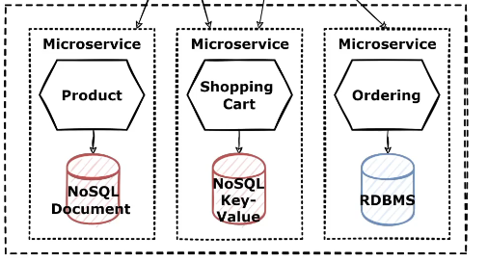

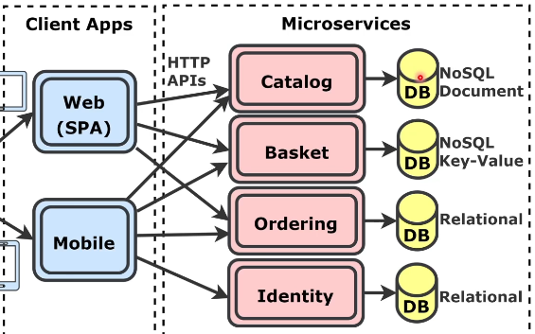

Svaki servis moze biti napisan u razlicitom jeziku kao I sto svaka baza moze biti razlicitog proizvodjaca.

Javlja se problem how to decompose services effectively.

**Microservices decomposition strategy:**

Resava problem decomposition effectively.

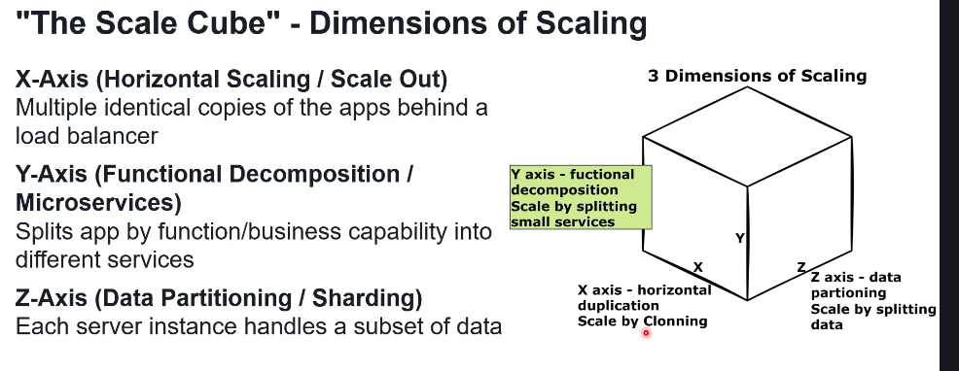

Svaki service komunicira sa drugim servicia indiriektnim putem Message Broker (RabbitMQ ili Kafka) ili direktno putem gRPC ili HTTP protokola, bez da jedni znaju bilo sta o drugima.

Decomposing patterns:

1. Decompose by business capability
2. Decompose by subdomain (Domain Driven Desing = DDD)

Strangler Fit pattern for transforming monolith to microservices.

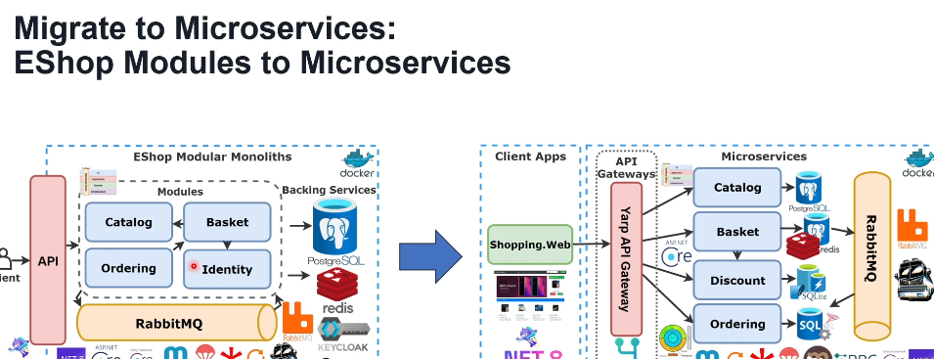

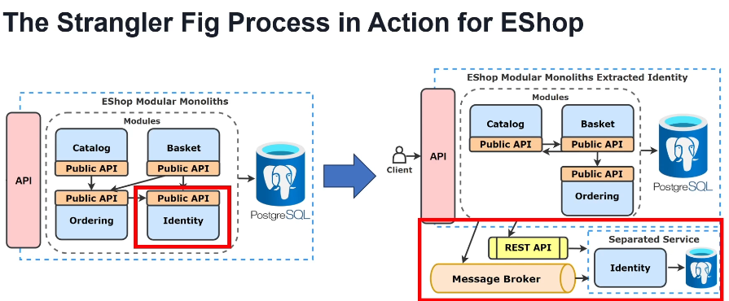

Nailazimo na problem kako servisi medjusobno komuniciraju I da li je to sync ili async.

**Microservice communication**

Kod modular monolith, modules su komunicirali direktno preko methoda, ali kod microservices to nije slucaj jer svaki service je ili na razlicitoj masini ili razlicit projekat pa ne moze tako direktno preko metoda. Inter-service communication via gRPC or HTTP protocols.

Sync inter-service communication

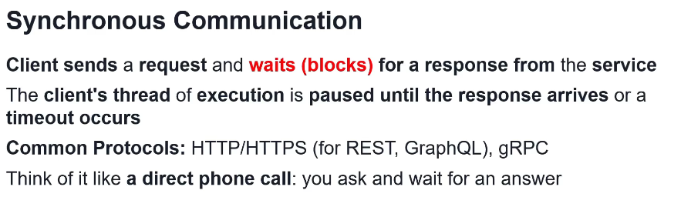

Sync communication je Request-Response

Async inter-service communication

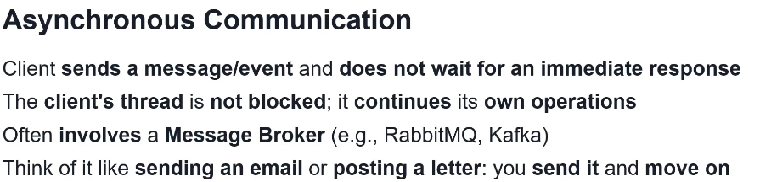

Async communication je Event-Driven, je svaka poruka u Message Broker se zove Event.

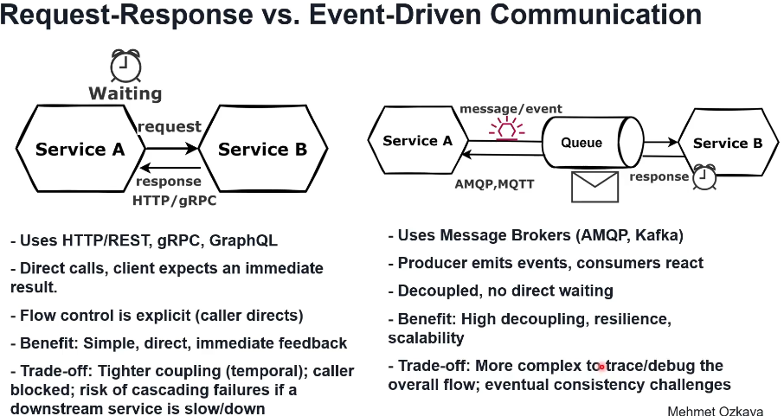

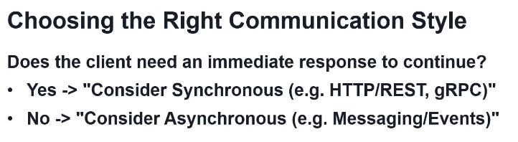

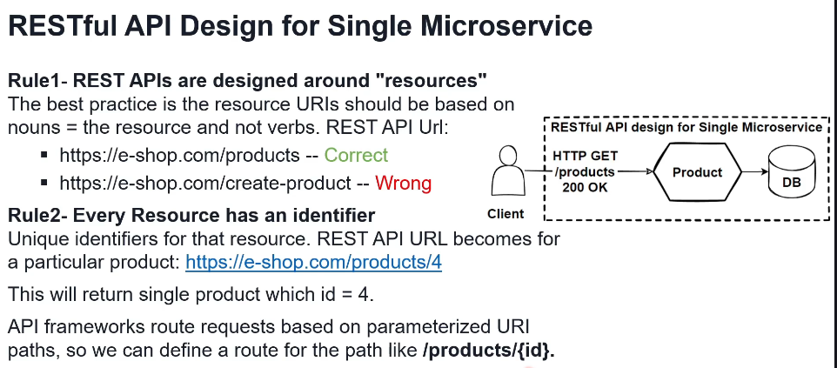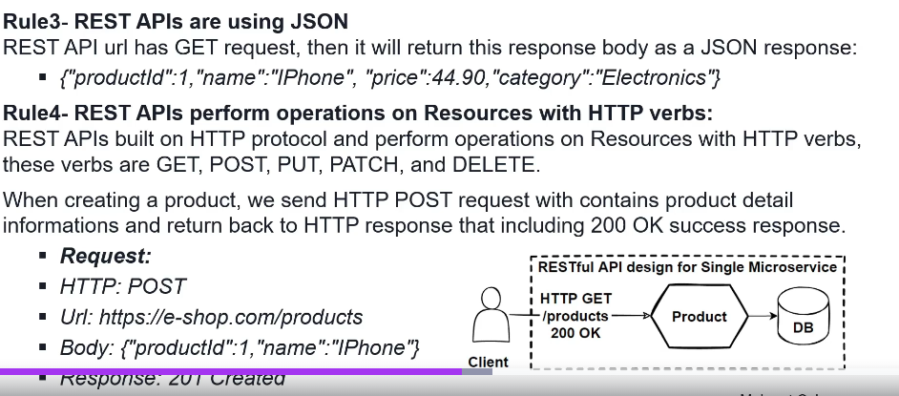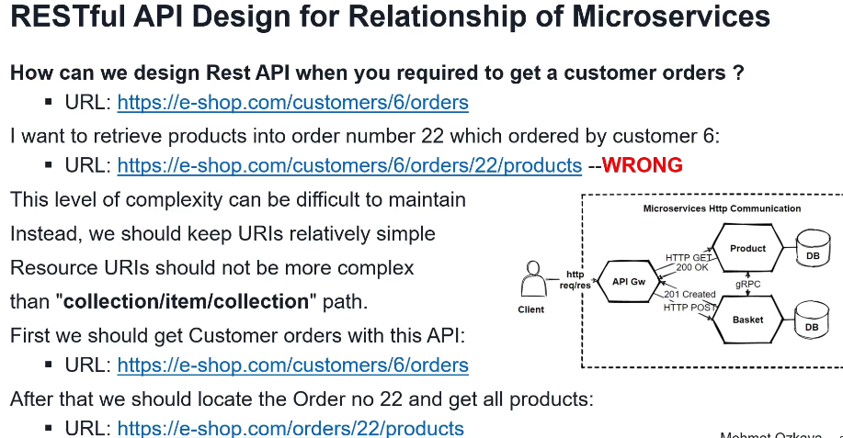

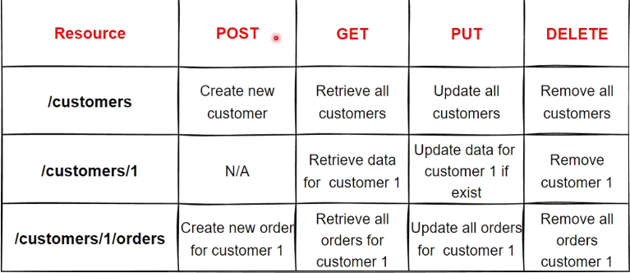

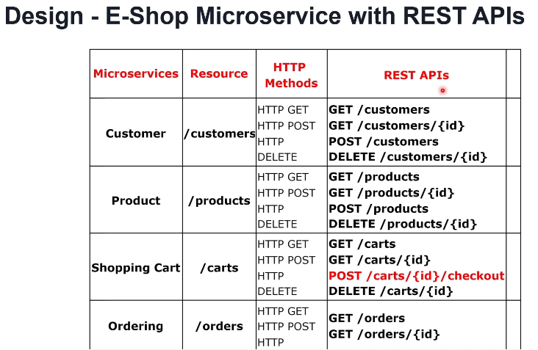

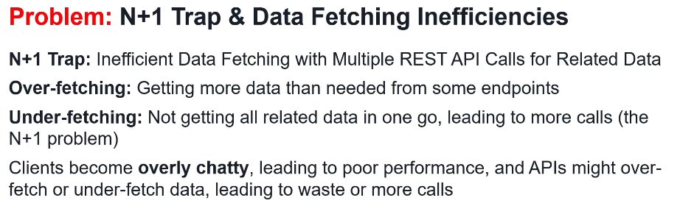

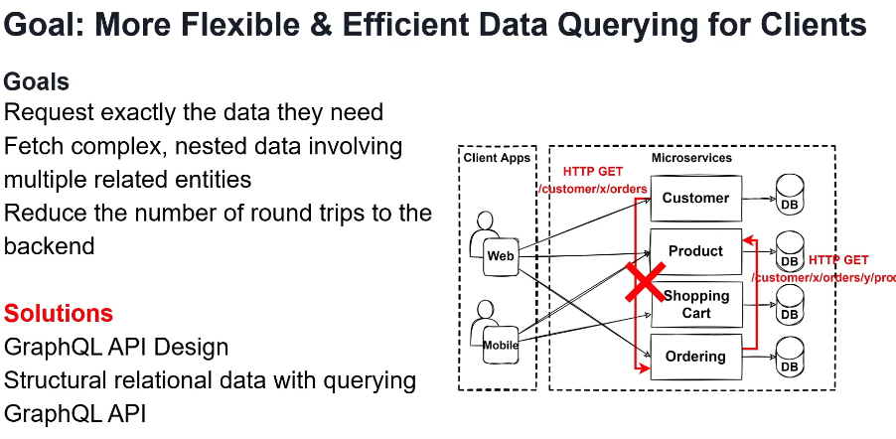

GraphQL

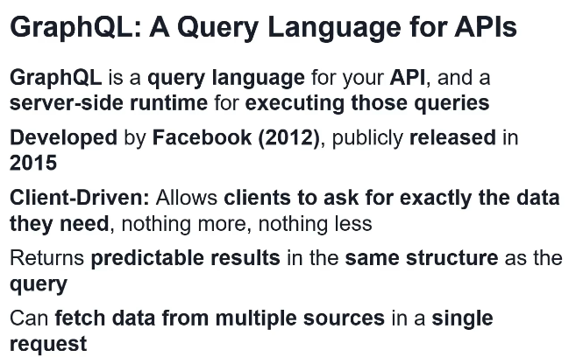

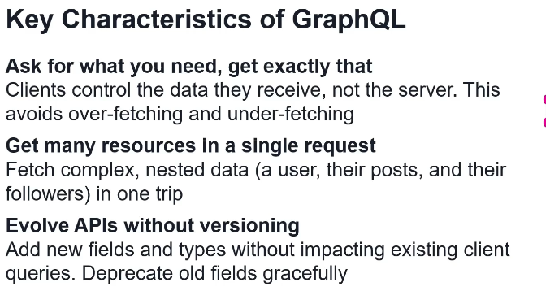

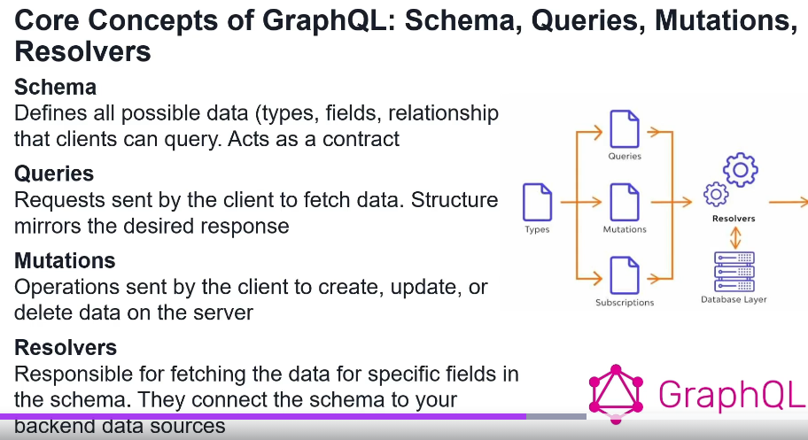

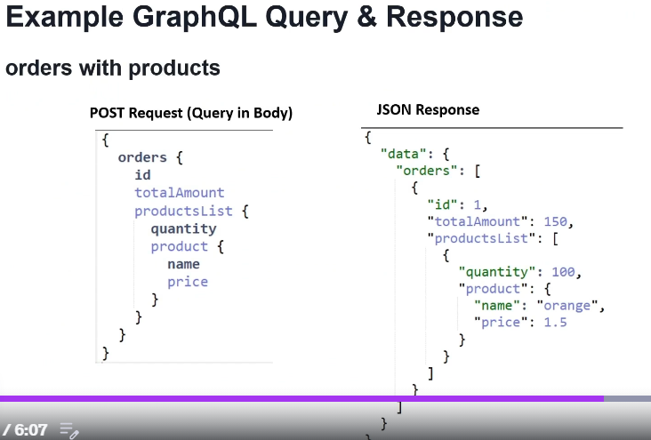

Primer razlike REST i GraphQL I kad se koji koristi



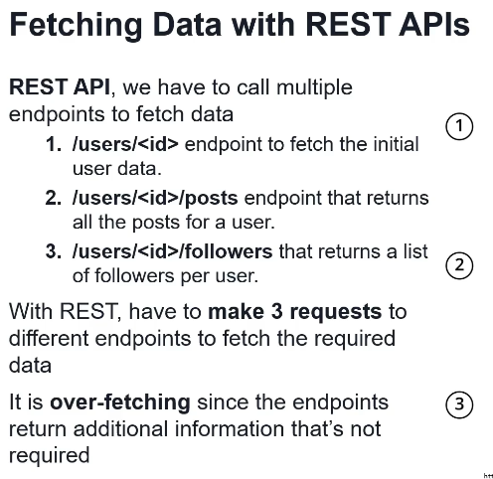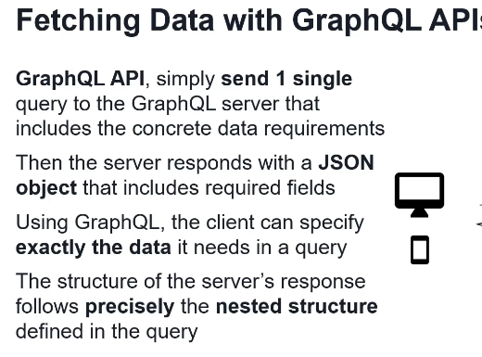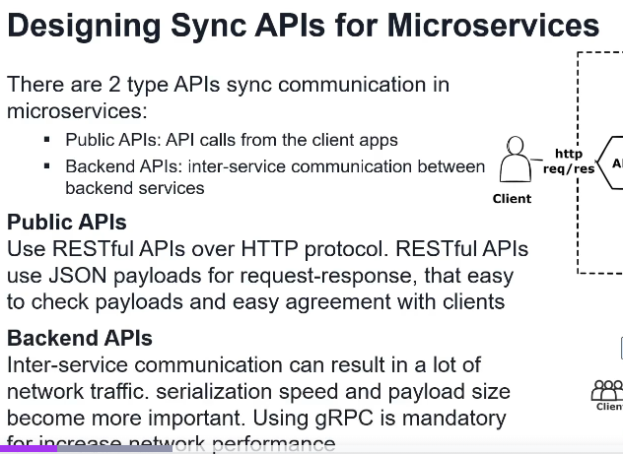

gRPC

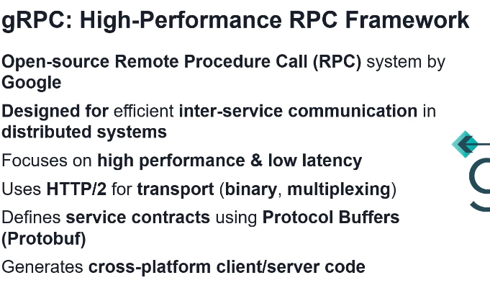

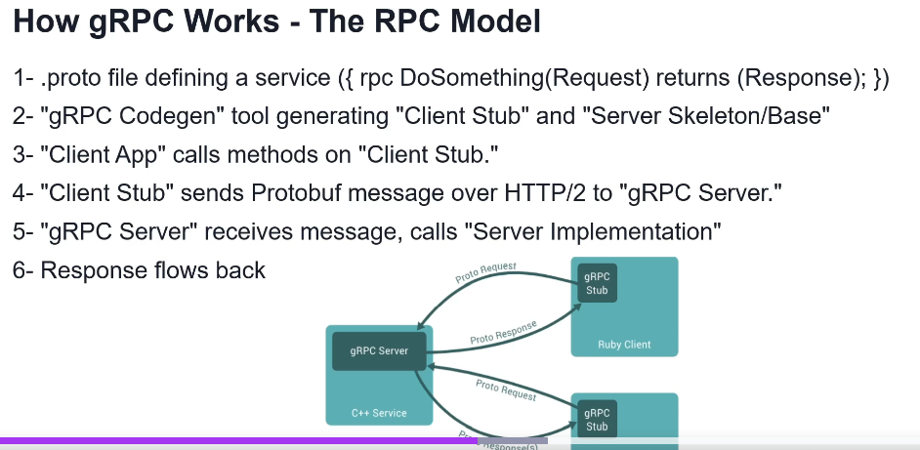

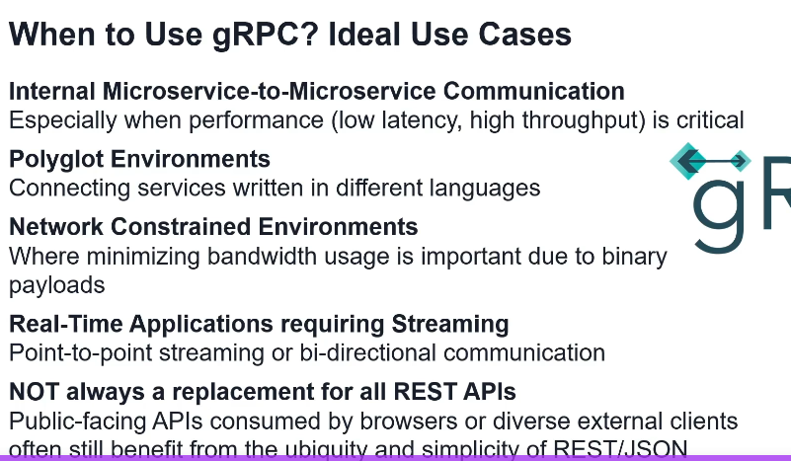

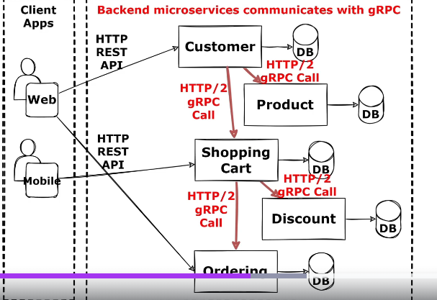

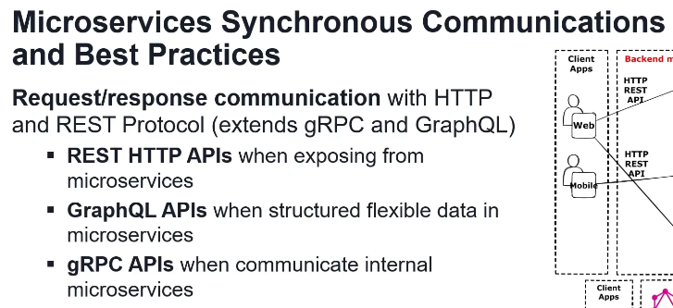

Znaci, REST i GraphQL je da Client komunicira sa BE, a gRPC izmedju microservices.

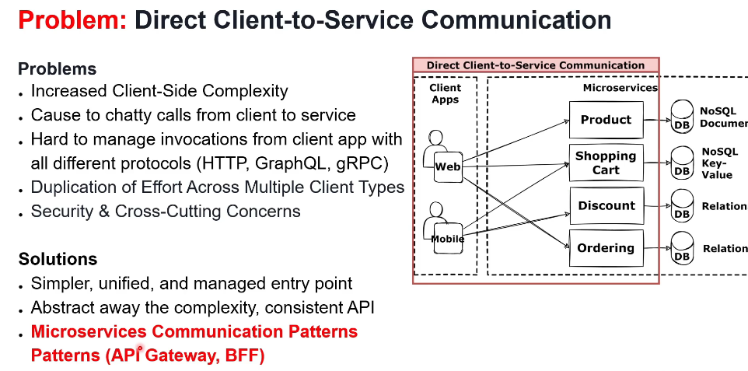

**Microservices communication – API Gateway:**

Resava problem direknte Client-Server(BE) komunikacije u microservices, jer u monolith API Gateway nema potrebe da postoji.

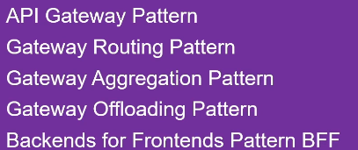

API Gateway stoji izmedju Client (FE) i Server(BE) I klijent kada gadja neki API URL iz BE on prvo nesvesno gadja API Gateway, jer se API Gateway definise ili u BE (YARP za .NET) ili 3rd party tool se ukljuci (Amazon ili Azure).

Gateway Routing pattern

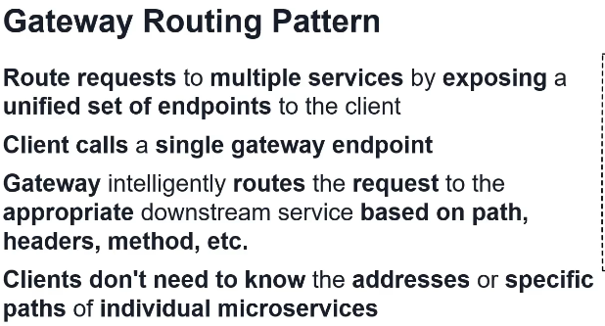

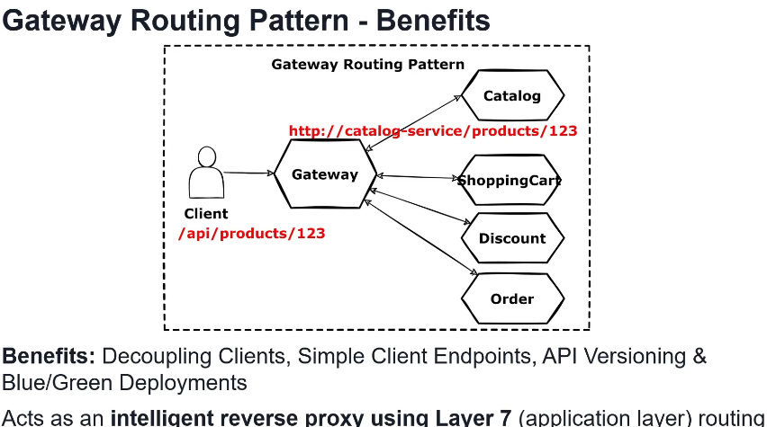

Gateway Aggregation pattern

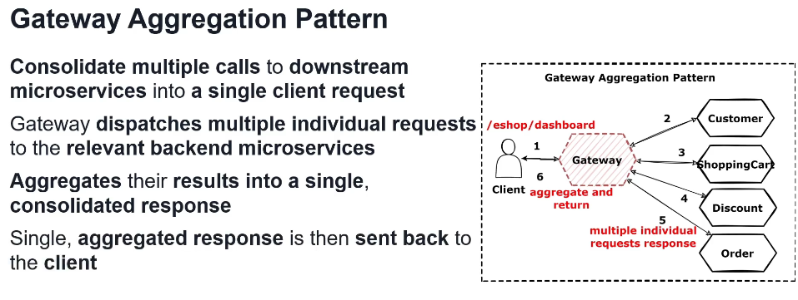

Gateway Offloading pattern

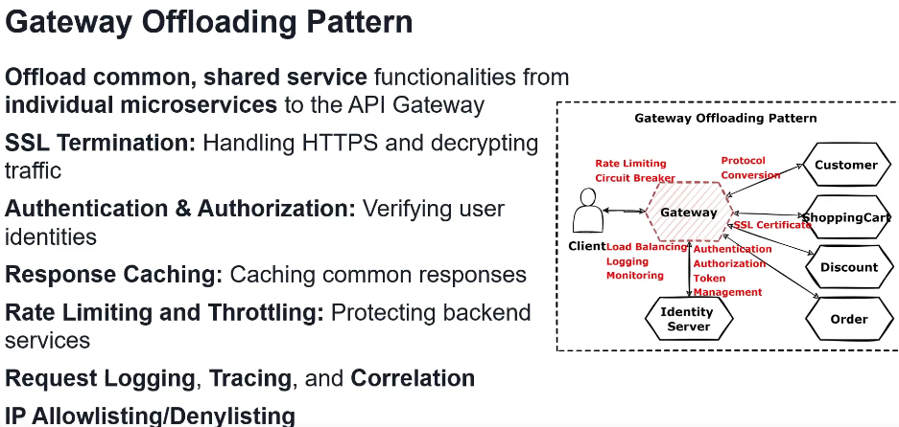

API Gateway pattern

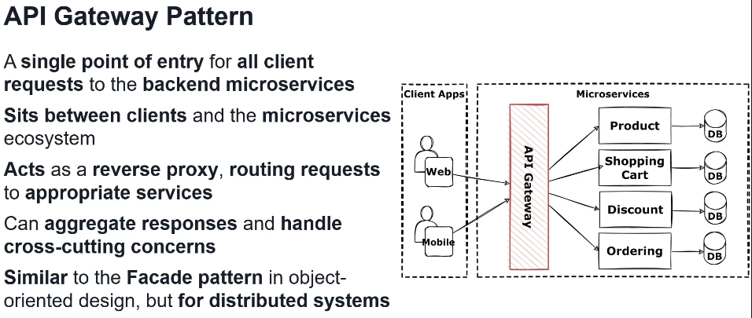

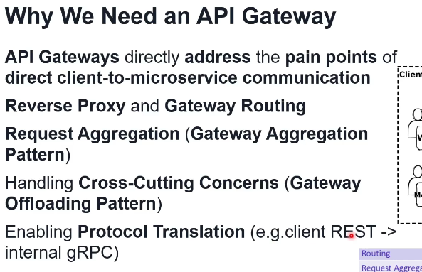

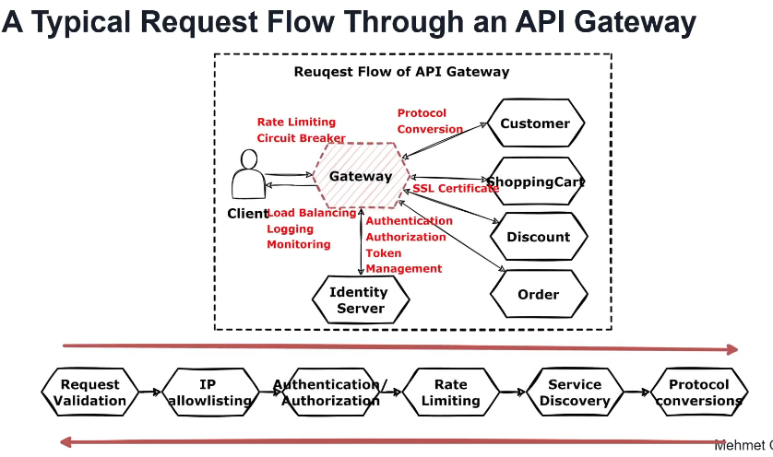

Vrste of API Gateway

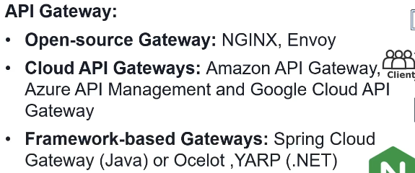

Pros and cons of API Gateway

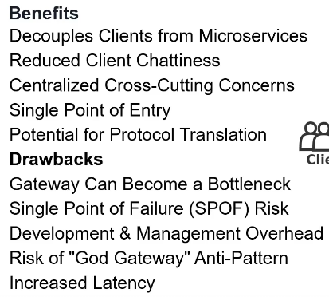

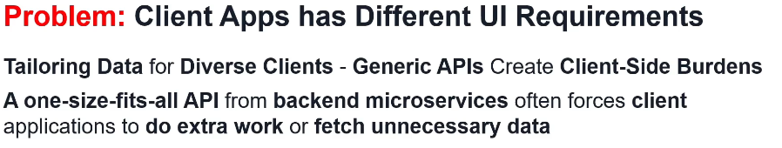

Problem je taj jer BE u danasnje vreme cross-platform (napisem npr .NET code i on sluzi I za web I za mobile FE apps), ali da ne bih pisao 2 razlicita BE, moram API Gateway da prepravim.

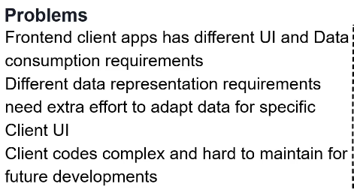



BFF patern ( Backend for Frontend pattern )

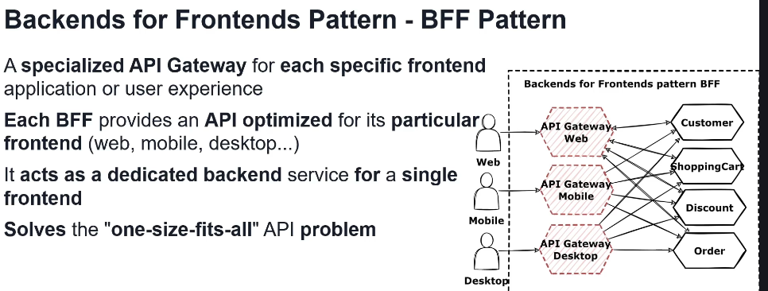

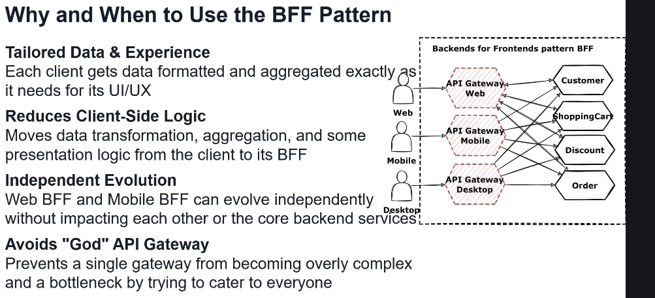

Service-to-service communication

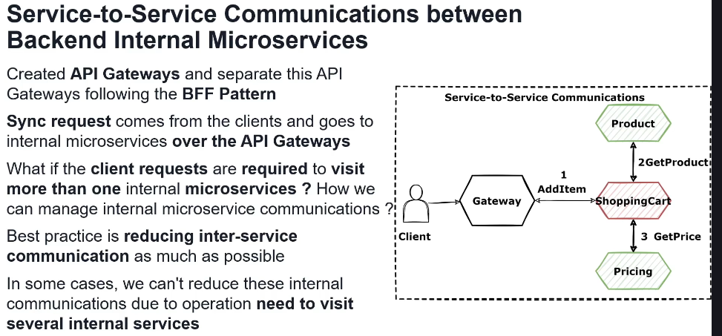

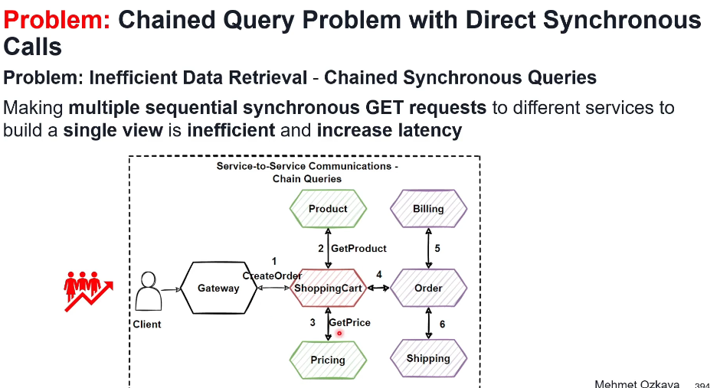

Service aggregator pattern

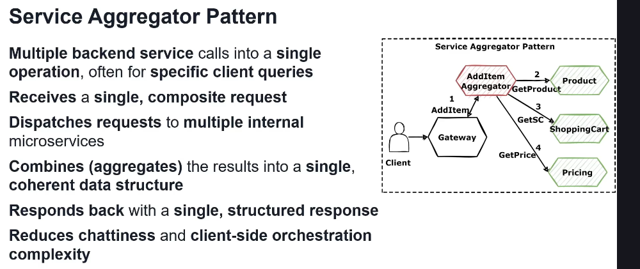

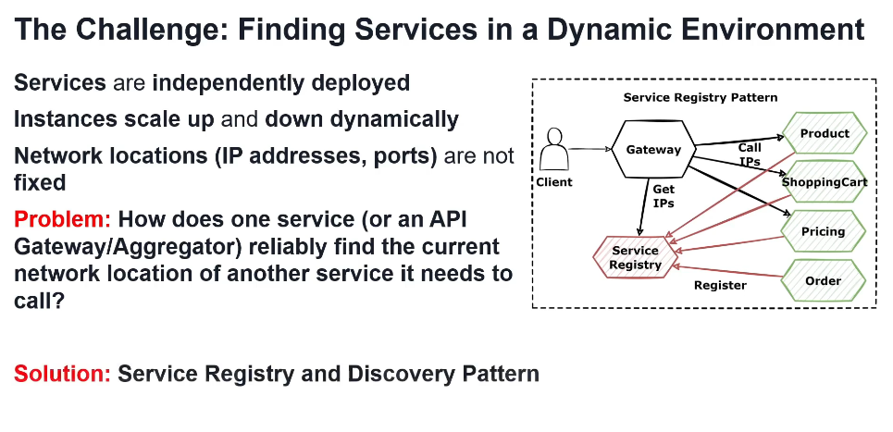

Service registry and discovery pattern

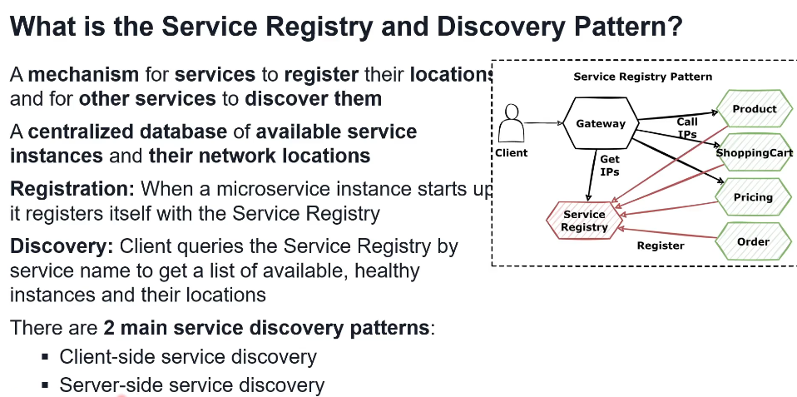

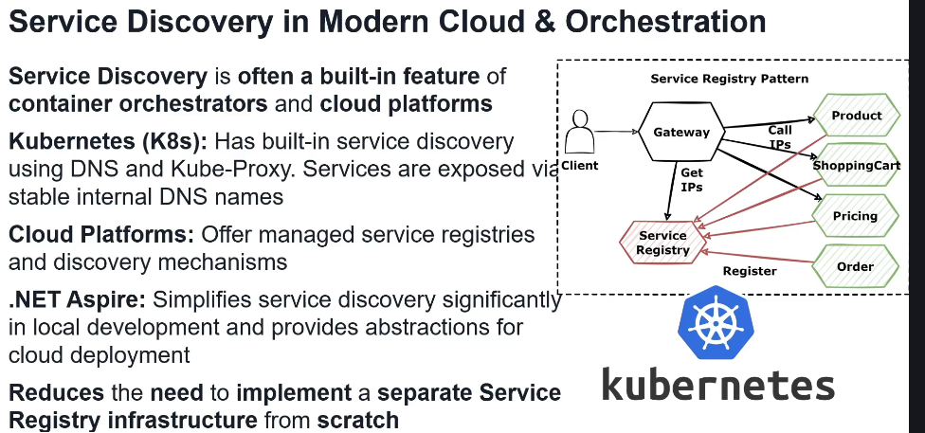

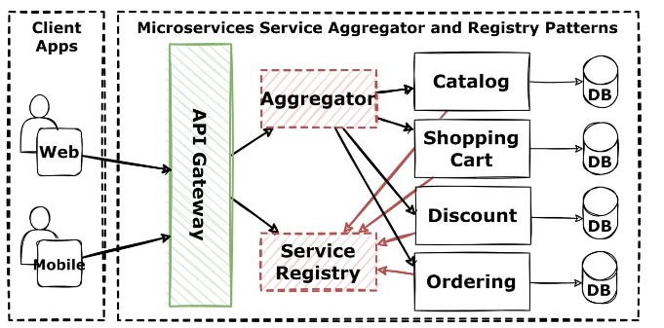

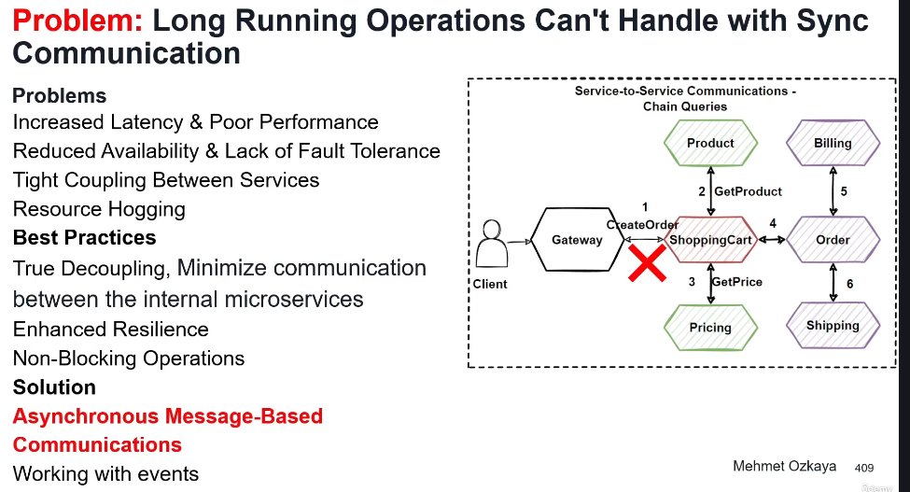

**Microservices Async communication & Event-driven architecture:**

Do sada, services su komunicirali synchronously direktno (gRPC kao najbolji protokol za to), ali to ima svojih nedostataka u pojedinim slucajevima kao sto su long running operations. Zato RabbitMQ ili Kafka stupaju na scenu kao Message Broker za async inter-service indirektnu komunikaciju gde servisi ne moraju znati nista jedan o drugome jer imaju posrednika.

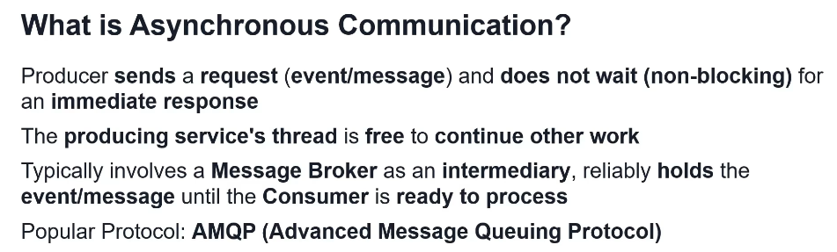

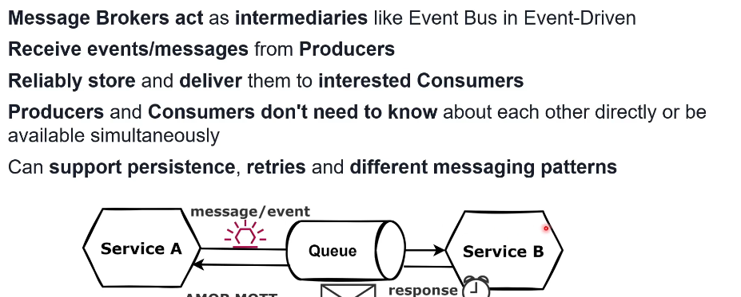

Two main types of async communication via Message Broker

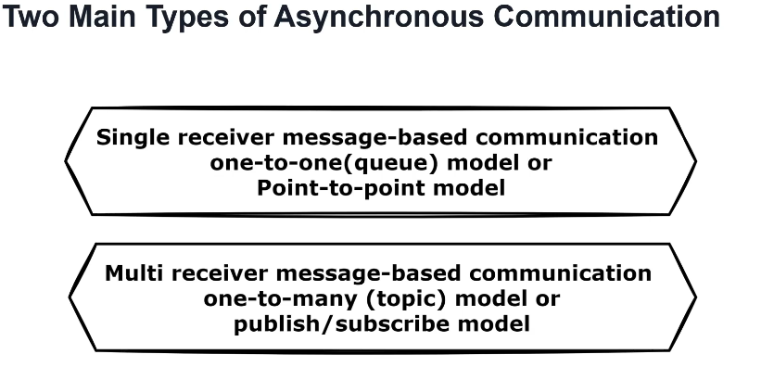

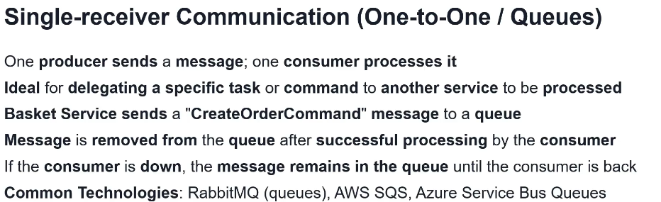

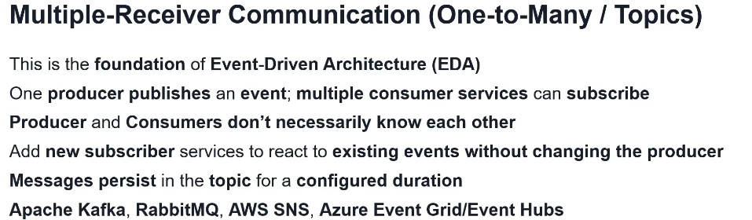

Combine sync and async communication between services

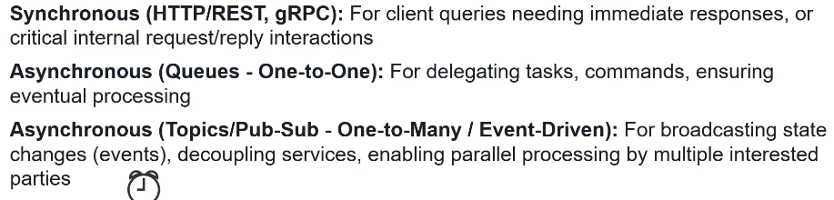

Event-driven architecture

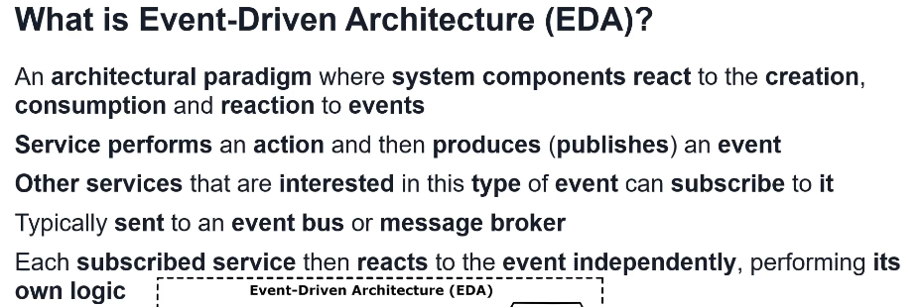

Publish-Subcsribe pattern

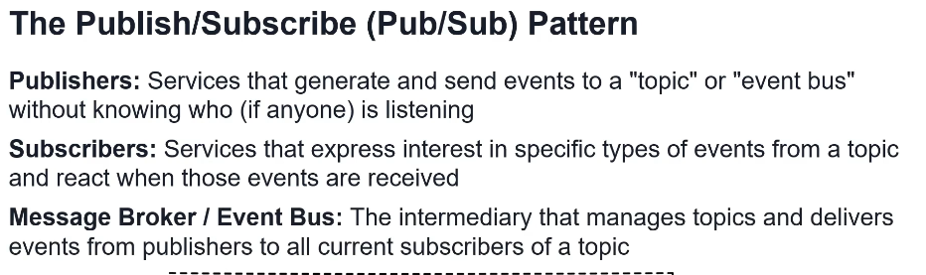

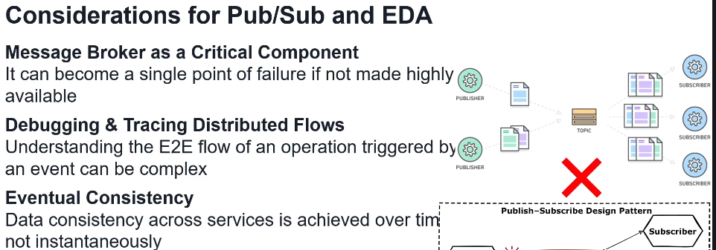

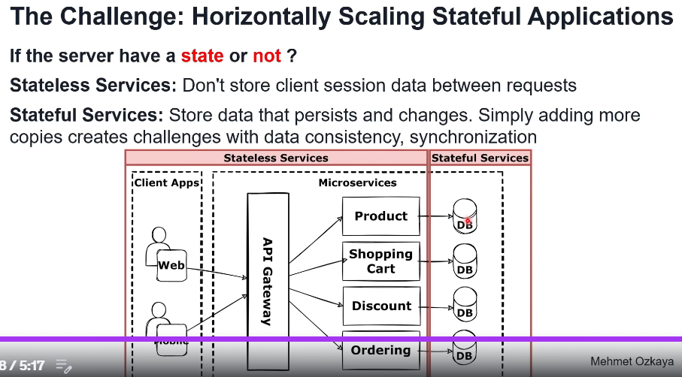



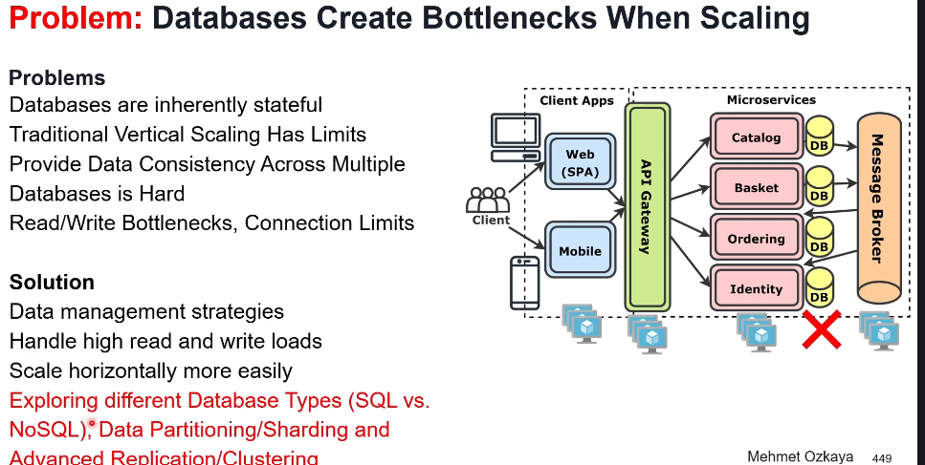

**Microservice data management – choosing right database:**

SQL db tesko moze horizontal scaling, vec samo vertical, jer imam user tabelu pa imam product tabelu I one su povezane kljucem obicno I ako te tabele stavimo u fizicki odvojene baze onda jebeno da ih povezemo.

NoSQL db moze horizontal scaling lagano, jer u jednom dokumentu (pandan vrsti u SQL tabeli) je sve za jednog korisnika recimo.

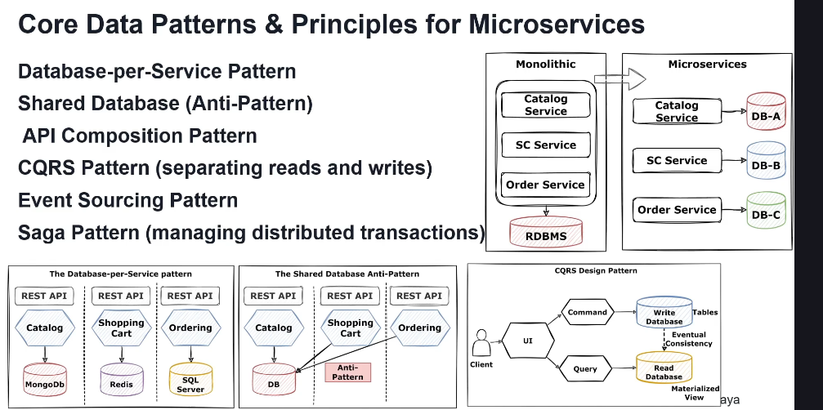

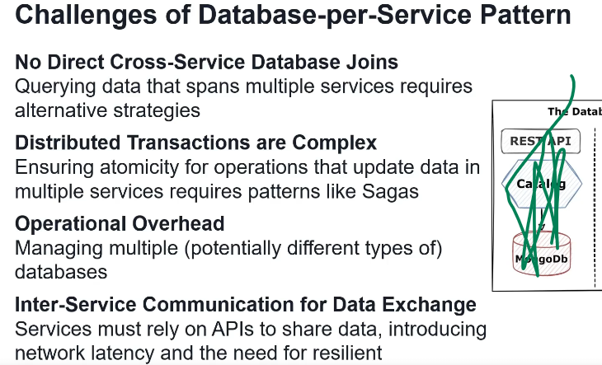

Svaki service mora imati svoju bazu (ako mu baza treba).

SQL db

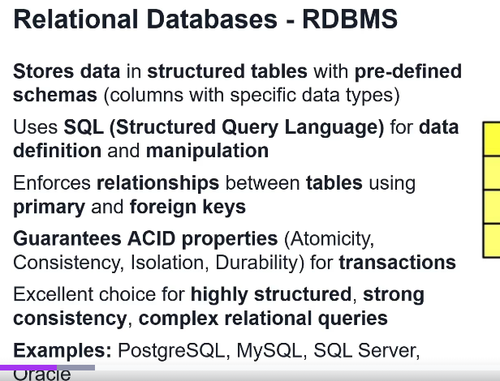

Mogu biti column ili row based.

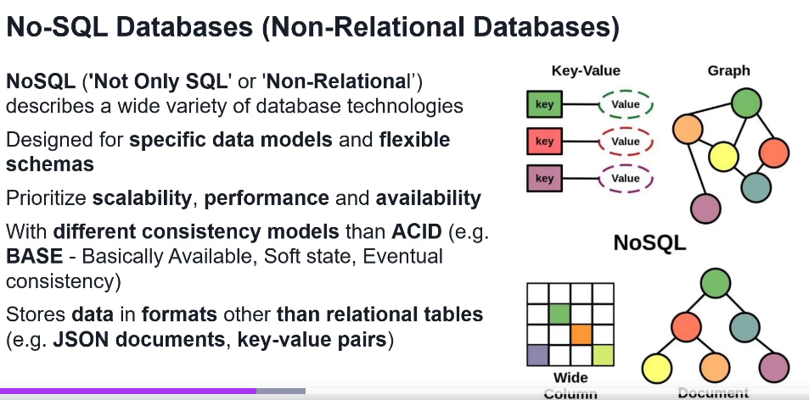

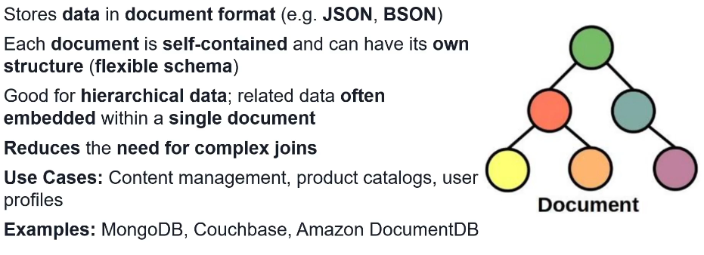

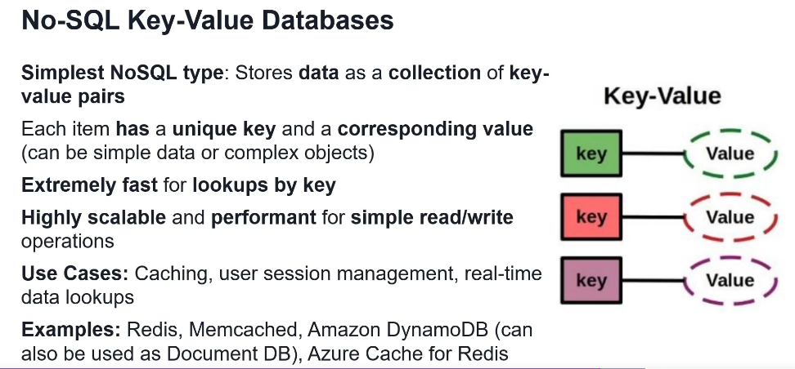

Obrati paznju, Redis je baza in-memory (u RAM ne na HDD kao ostale), se koristi za cache, jer brzo dohvatanje na osnovu key-value pair formata je najbrze.

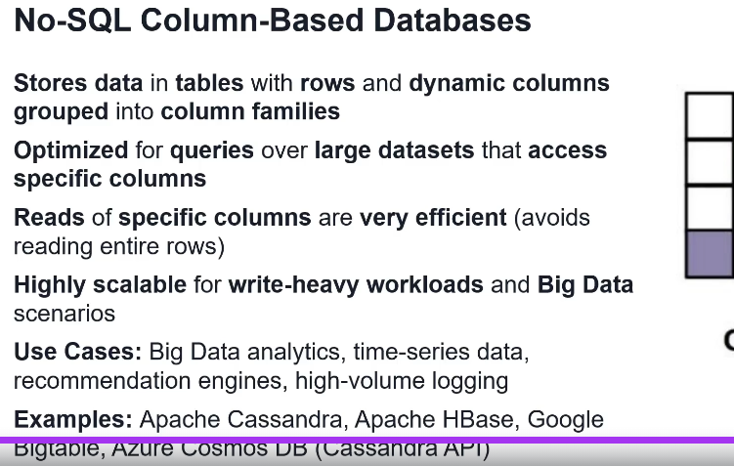

Ovo prvi put cujem NoSQL column-based

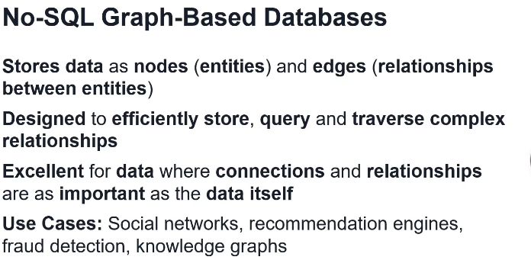

When to use SQL db

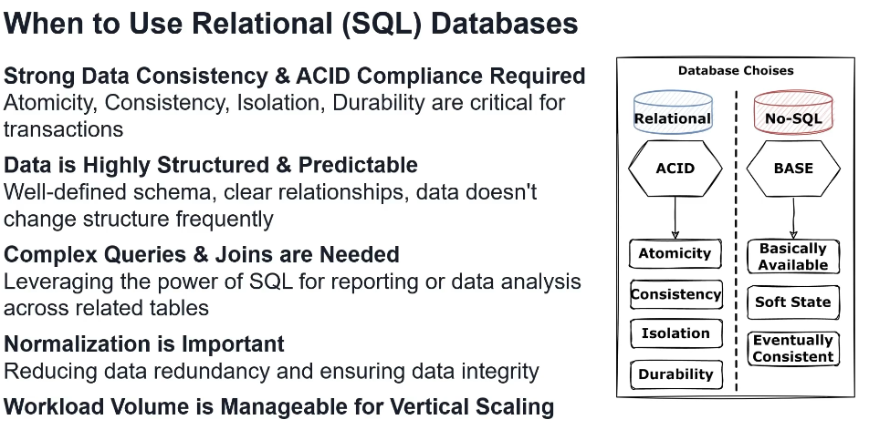

When to use NoSQL db

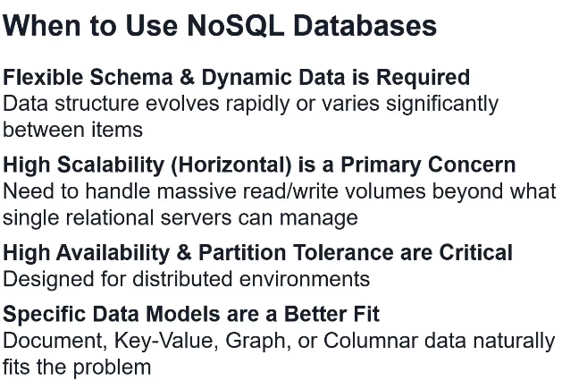

CAP teorema- how to choose db for microservice

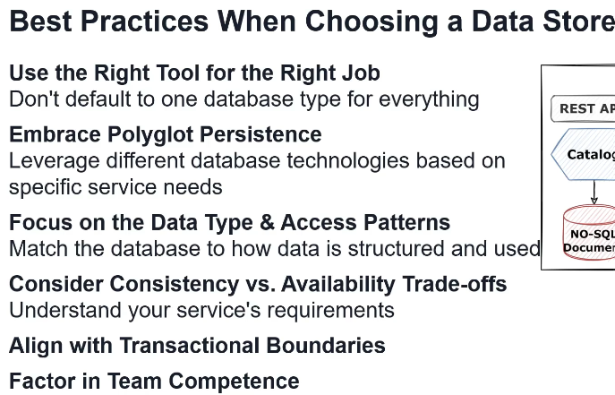

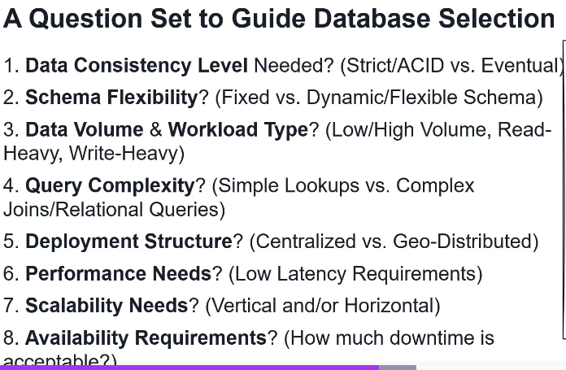

CAP

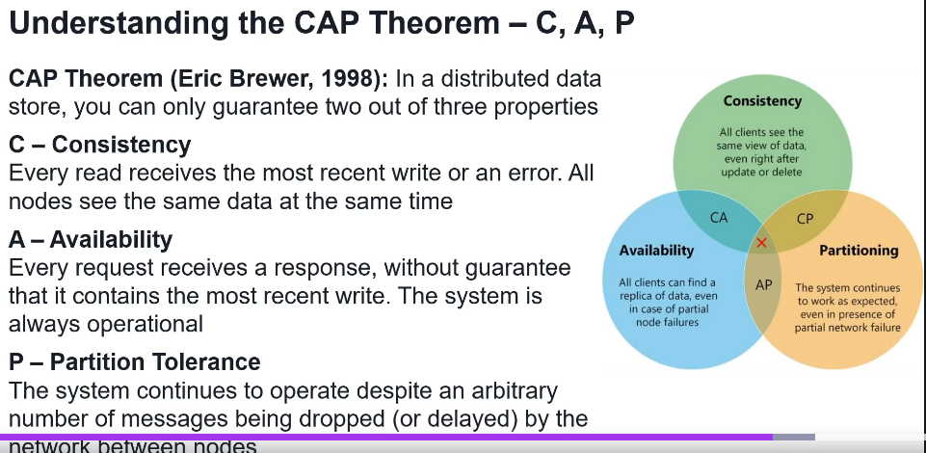

Limitacije single instance of microservice’s db

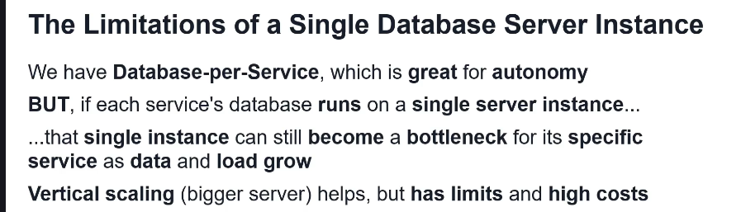

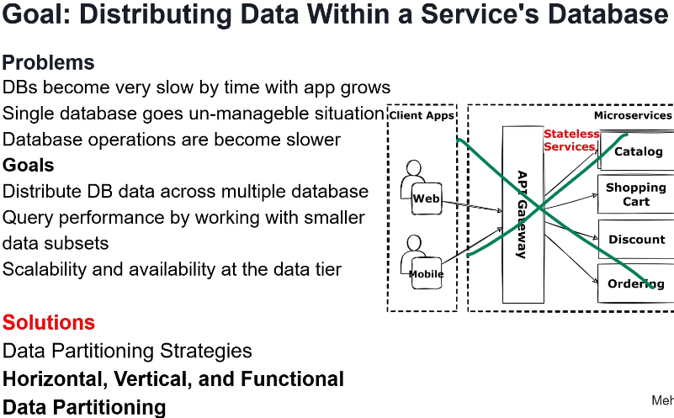

Data portioning strategies (Horizontal, Vertial and Functional)

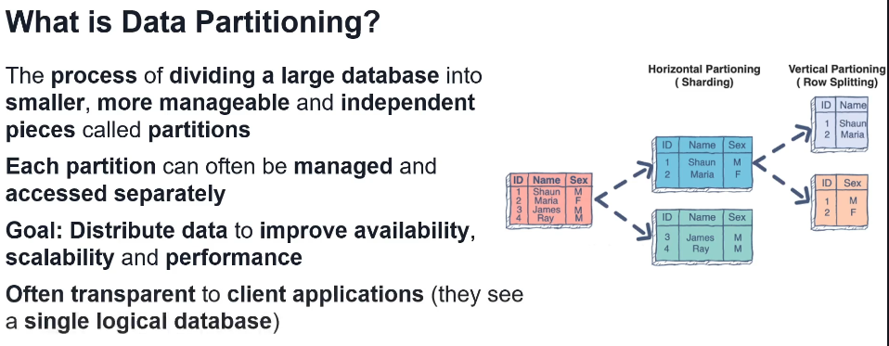

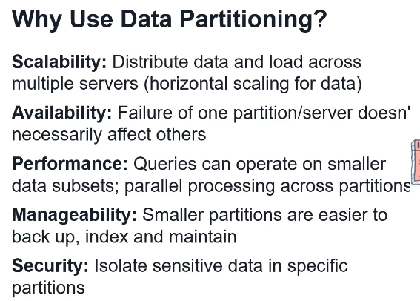

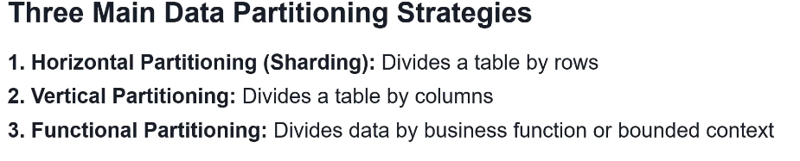

Horizontal partitioning (sharding)

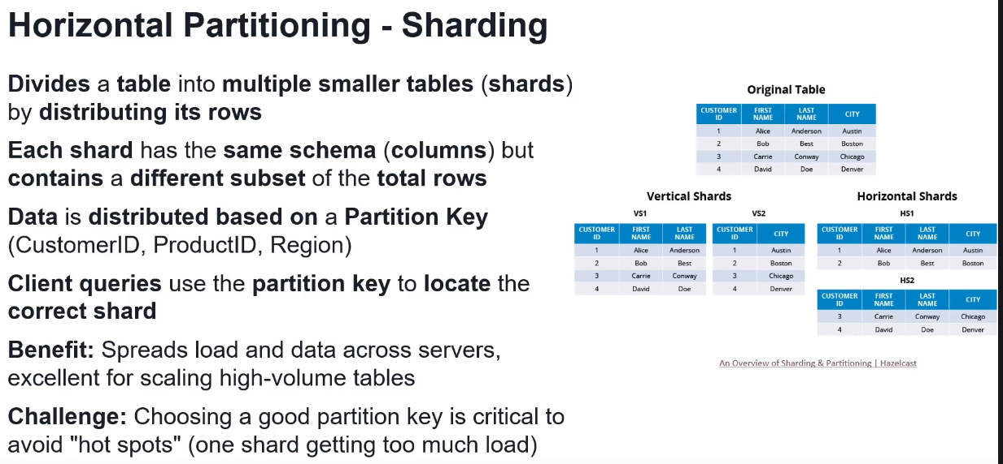

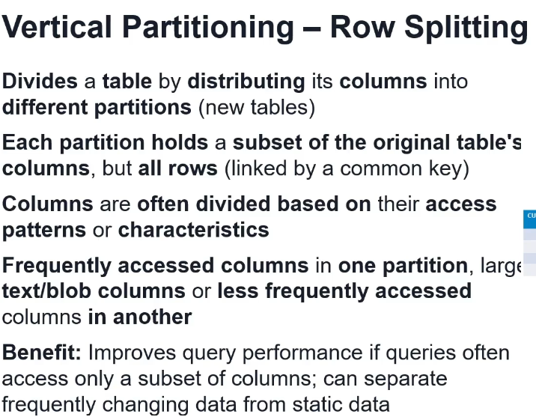

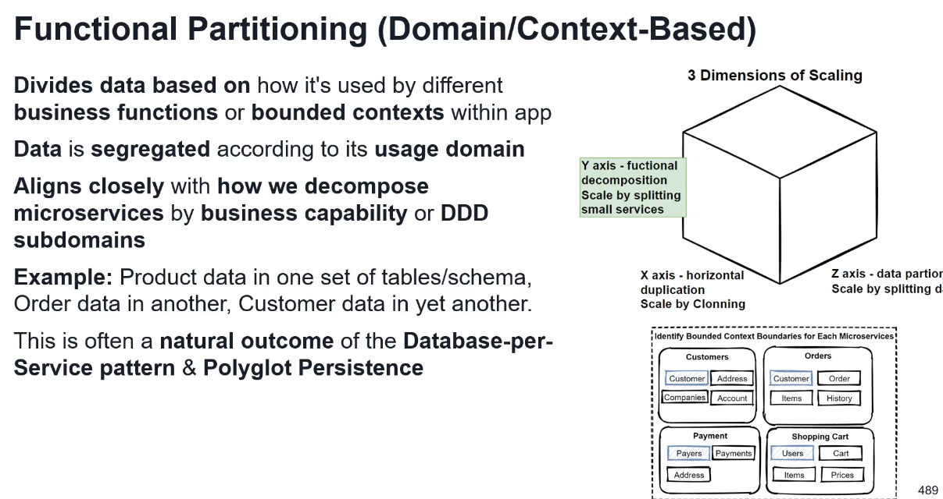

Db sharding (horizontal partitioning)

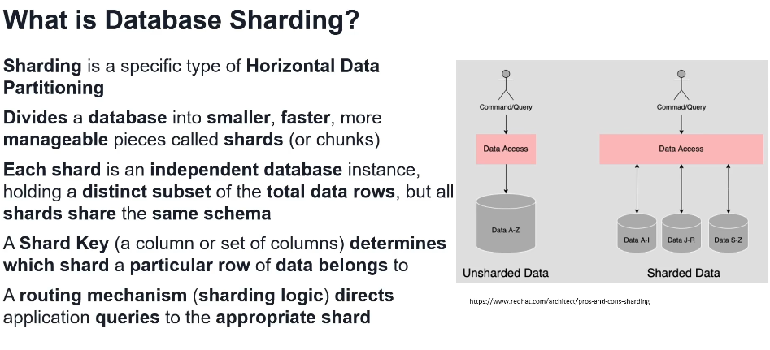

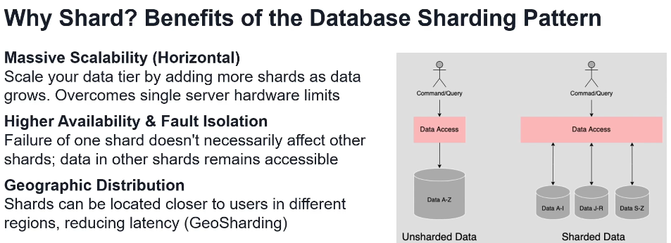

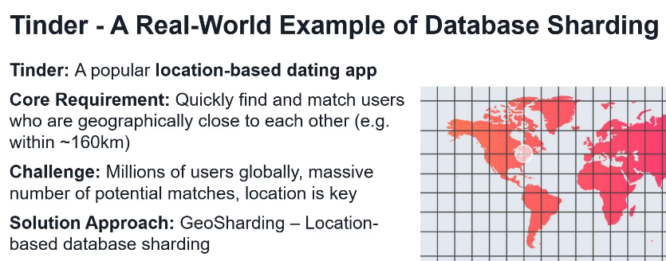

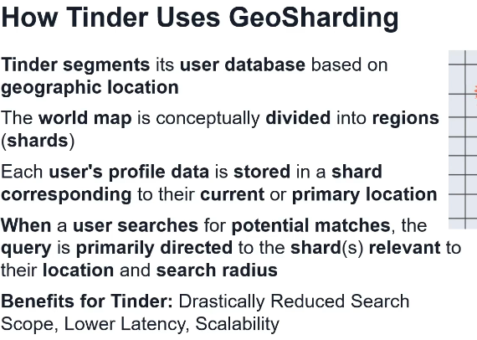

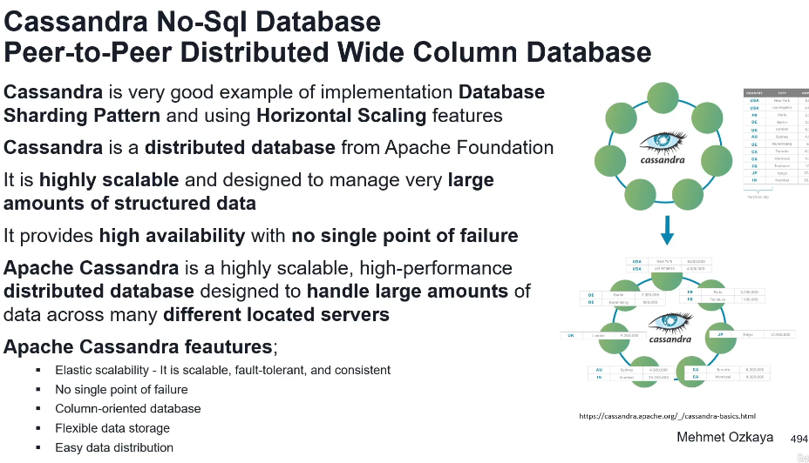

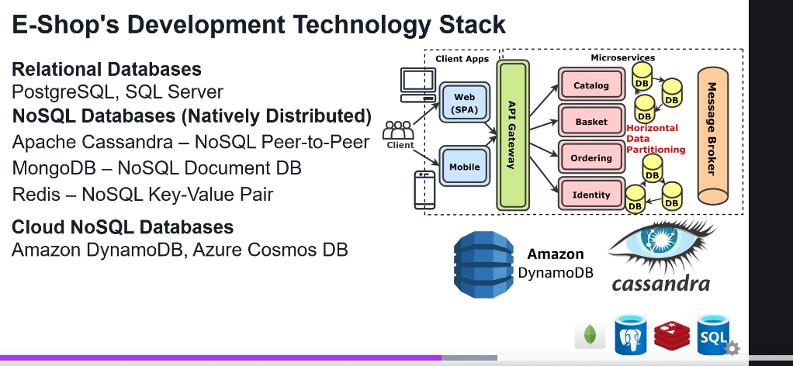

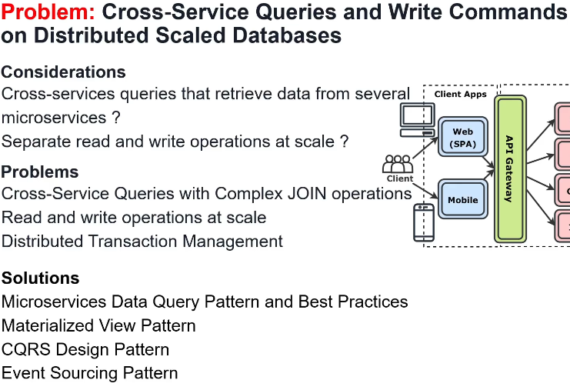

**Microservices data management – Command & Query**

Separates read and write operation on db

Materialized view

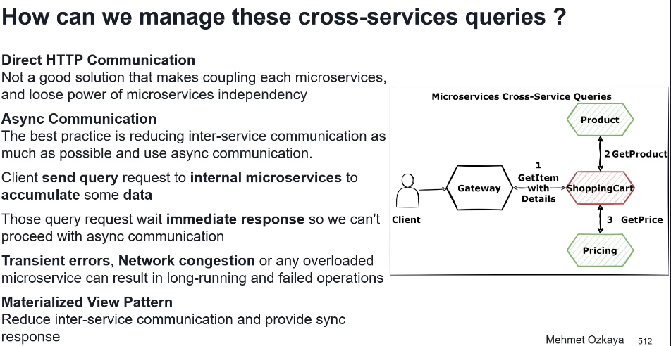

Materialized view

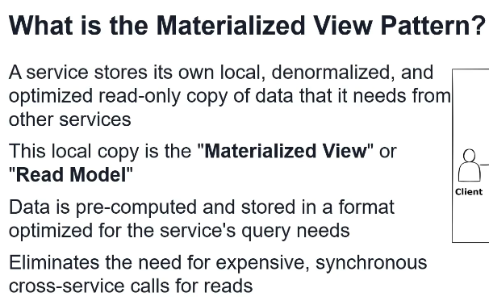

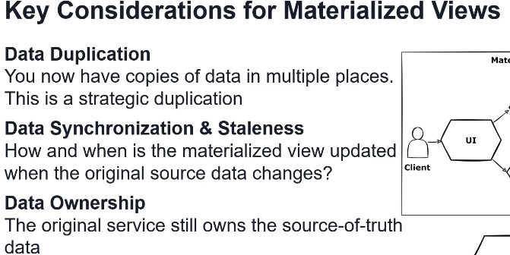

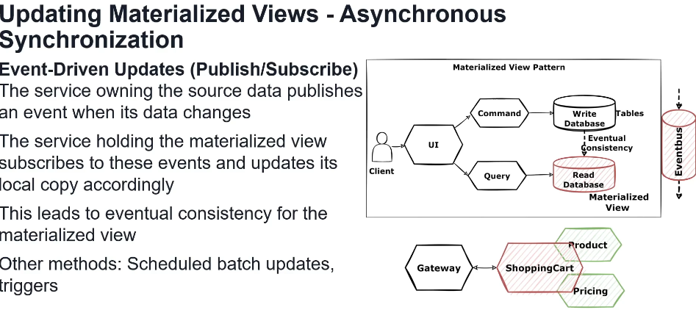

CQRS

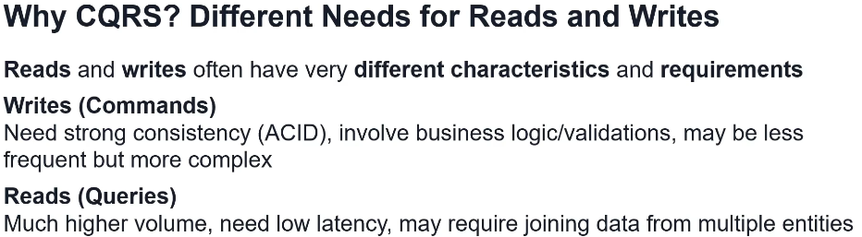

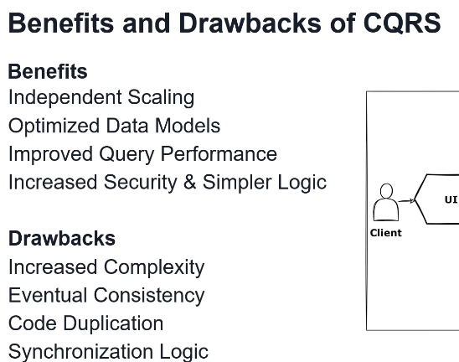

Kazu najbolje imati bazu za Read I bazu za Query tj 2 baze za svaki service kome treba baza, ali ja obicno radim I Command I Query na istu bazu jer mi app nije komplexna. Ovo je za complex slucajeve.

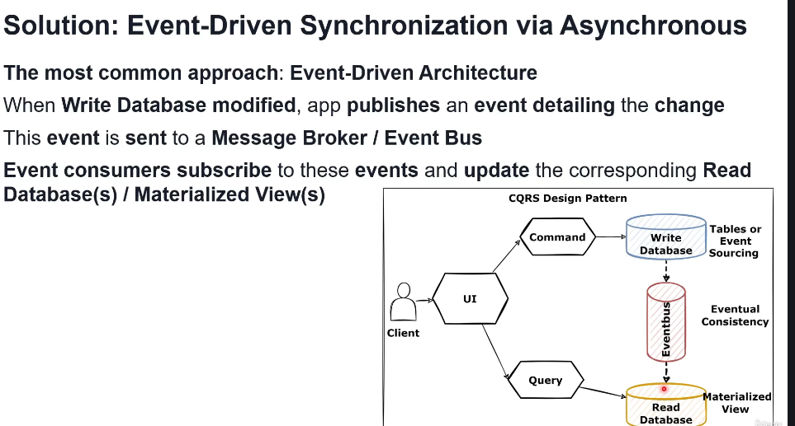

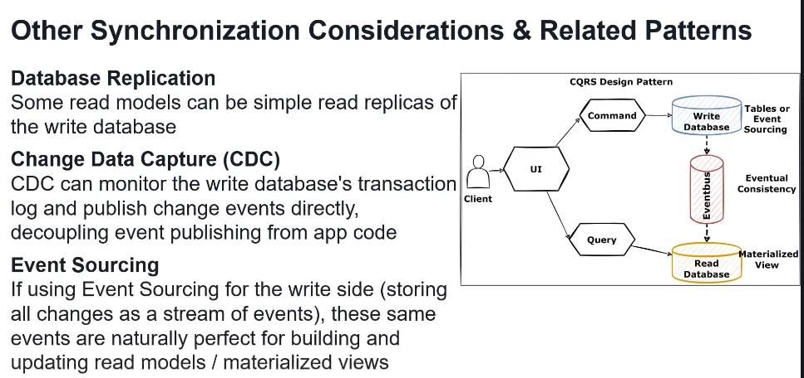

Event Sourcing

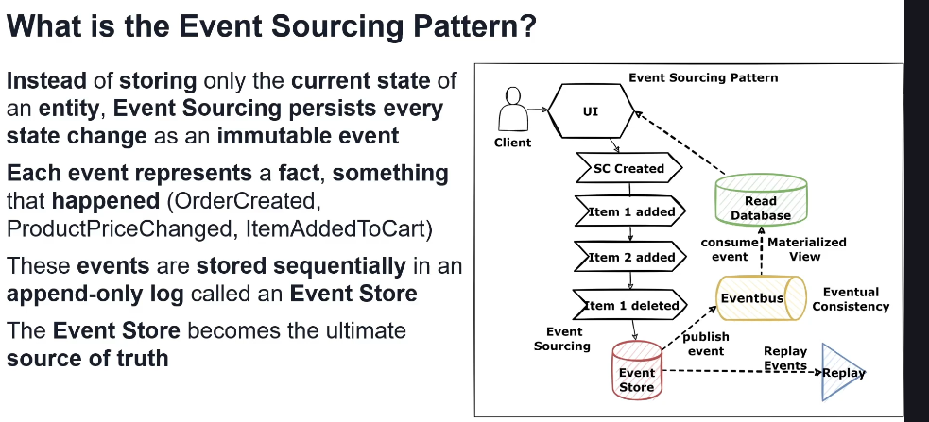

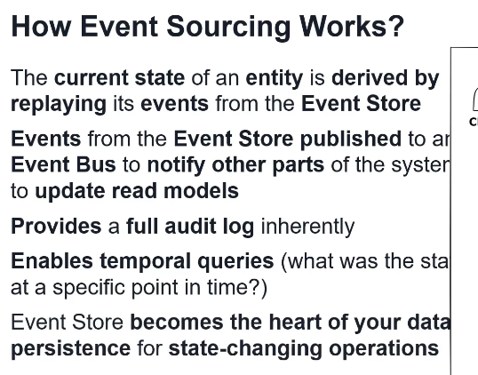

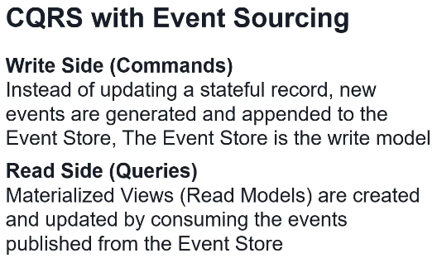

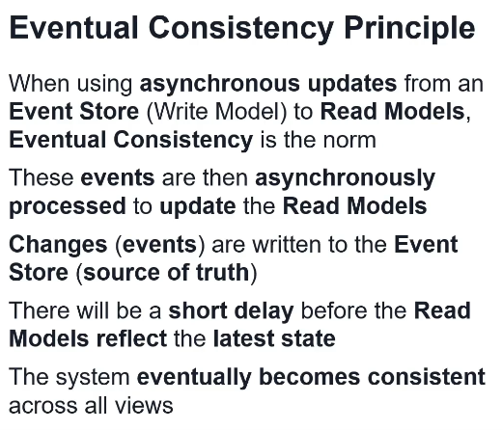

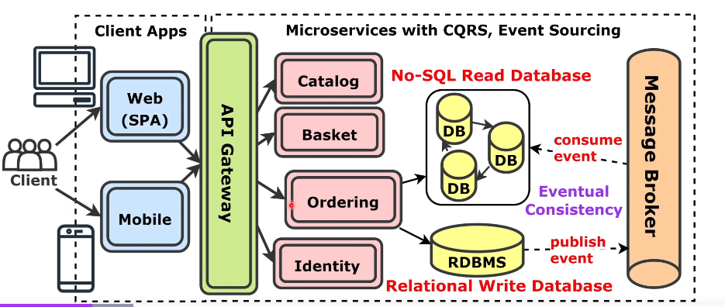

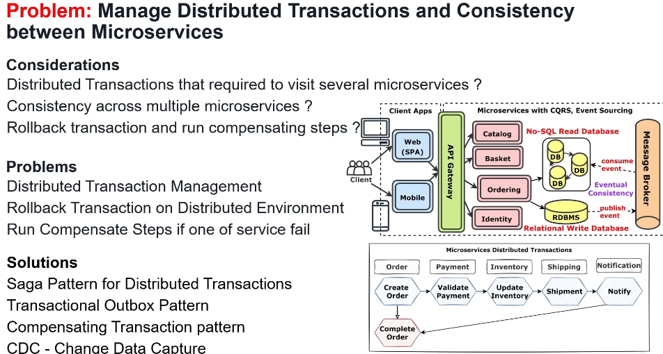

**Microservices data management – distributed transactions:**

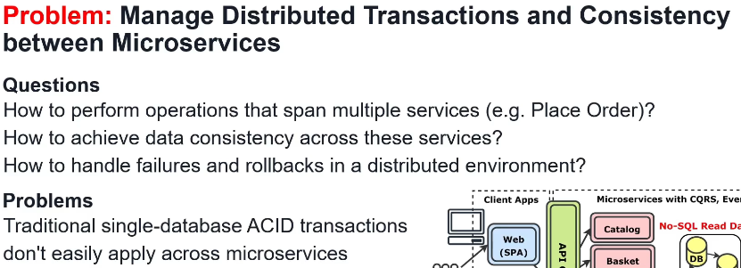

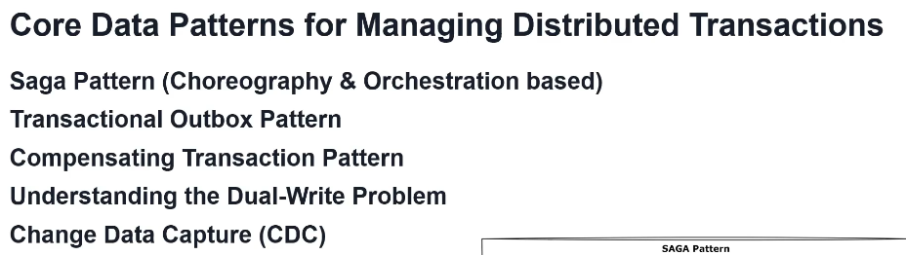

What is transaction

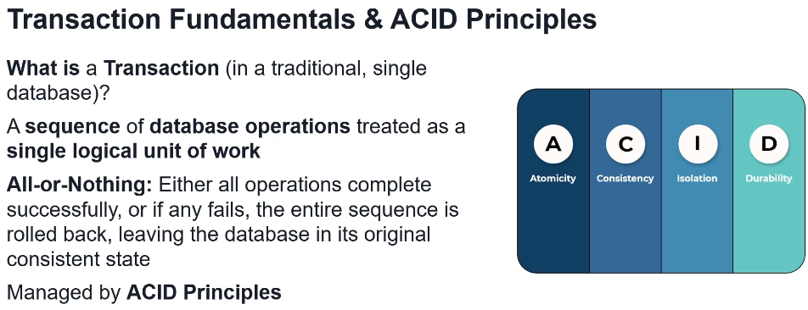

Transaction in Monolith architecture

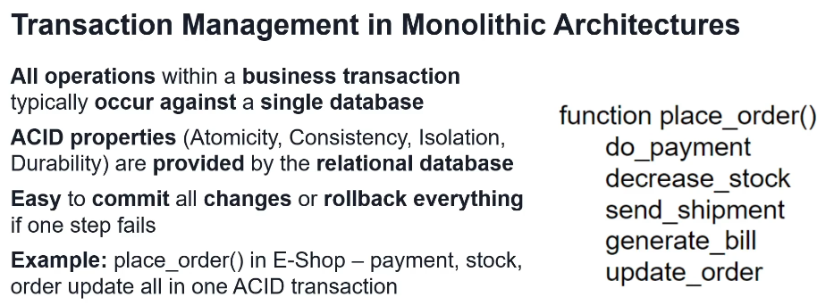

Why distribured transactions are hard

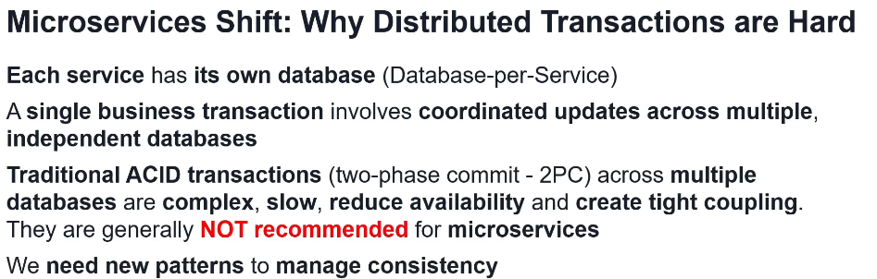

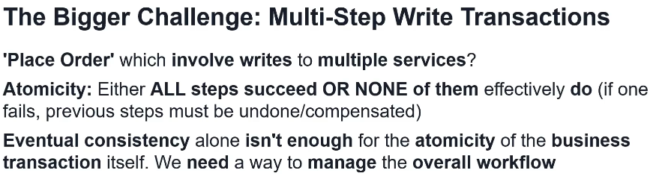

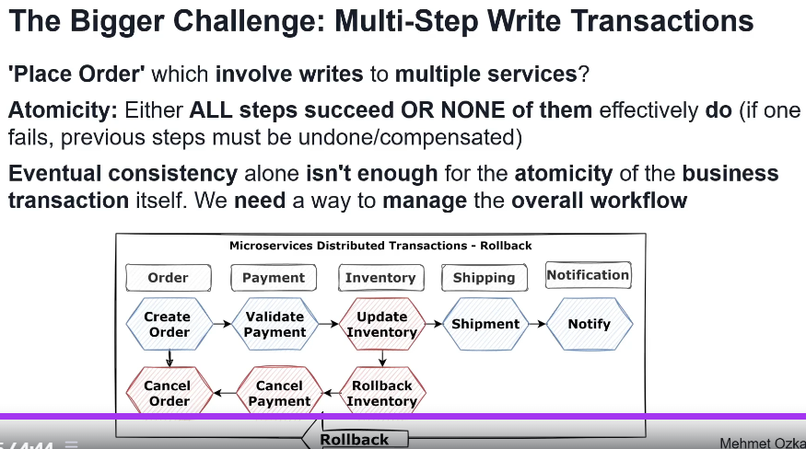

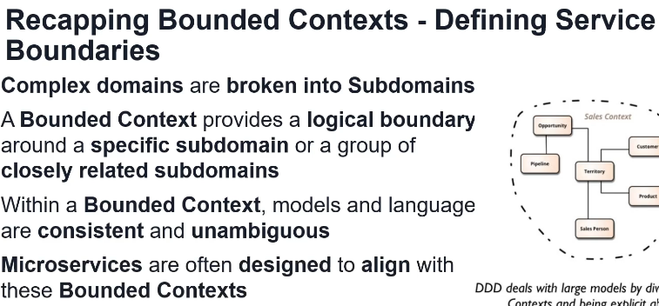

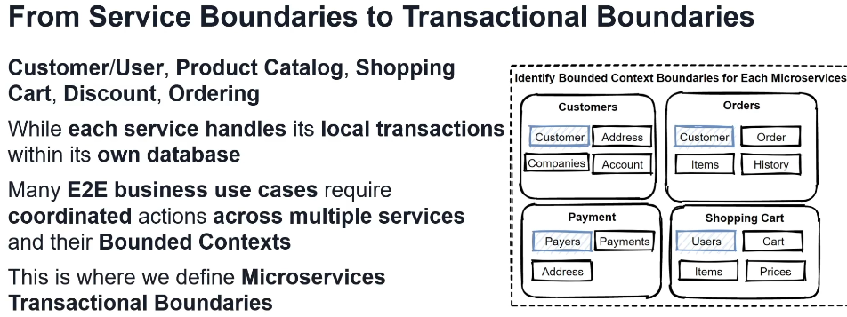

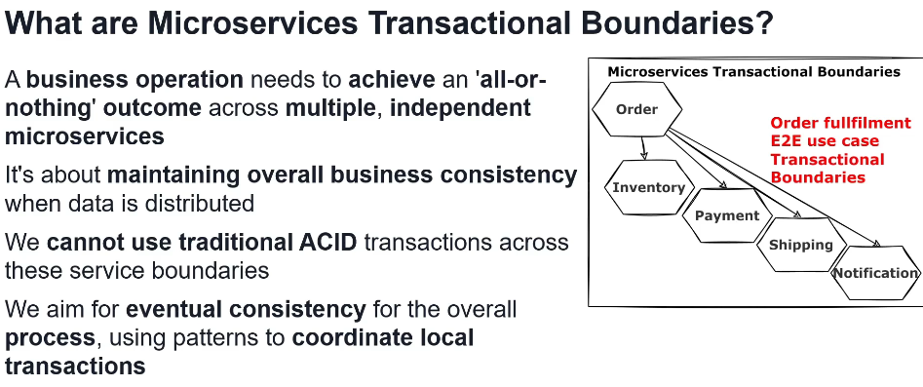

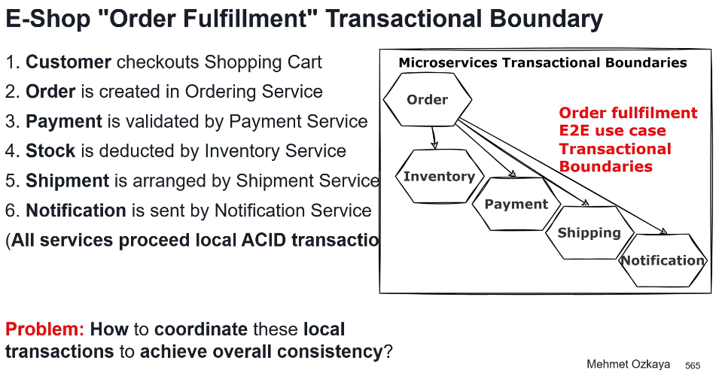

SAGA pattern – zahteva Message Broker for inter-service communication

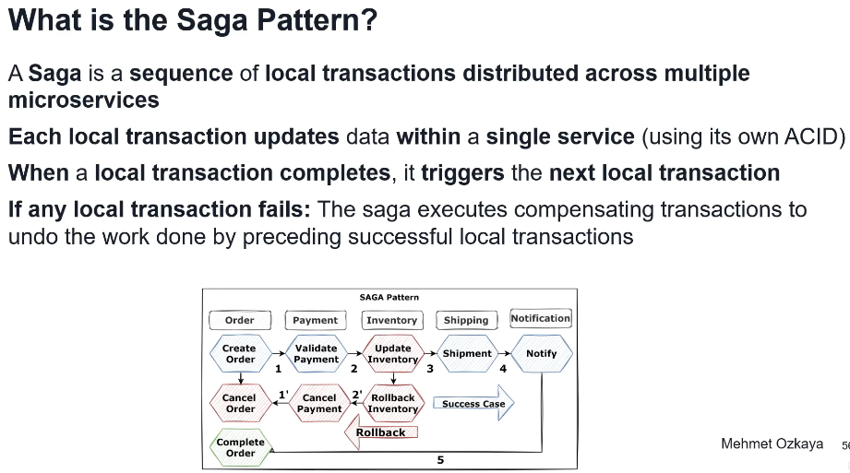

Saga types



Choreography-based SAGA

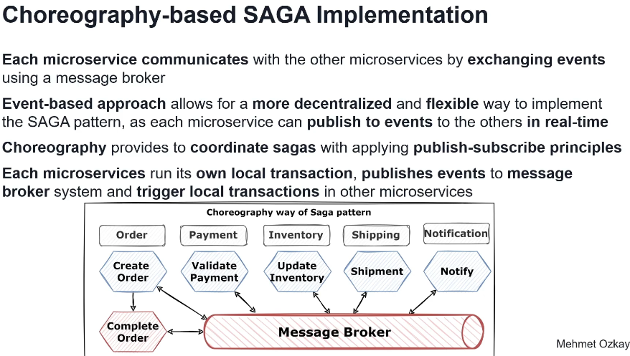

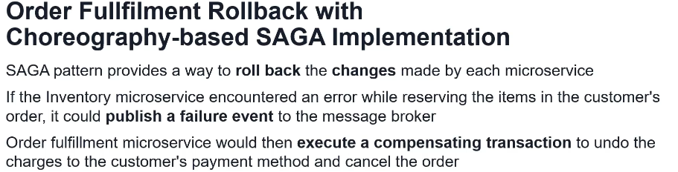

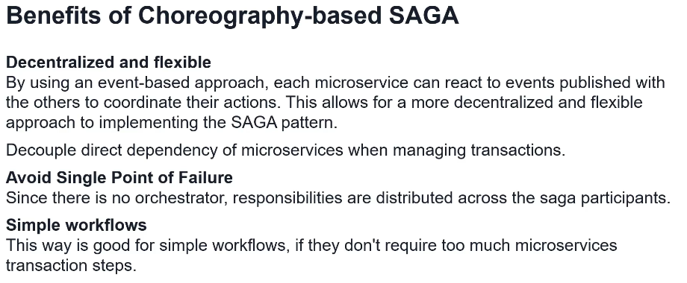

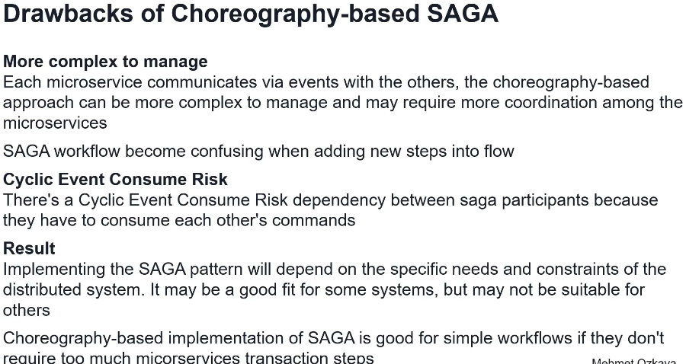

Orchestration-based SAGA

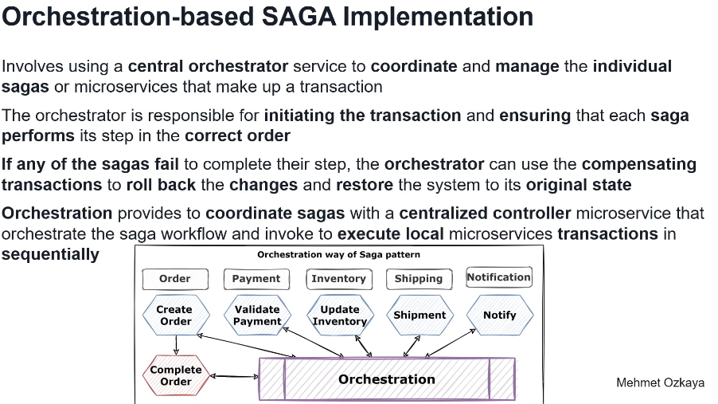

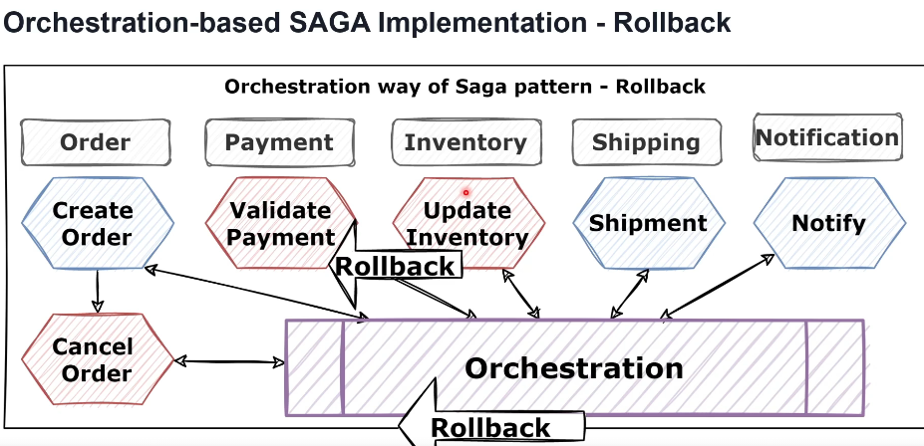

Compensating transactional pattern

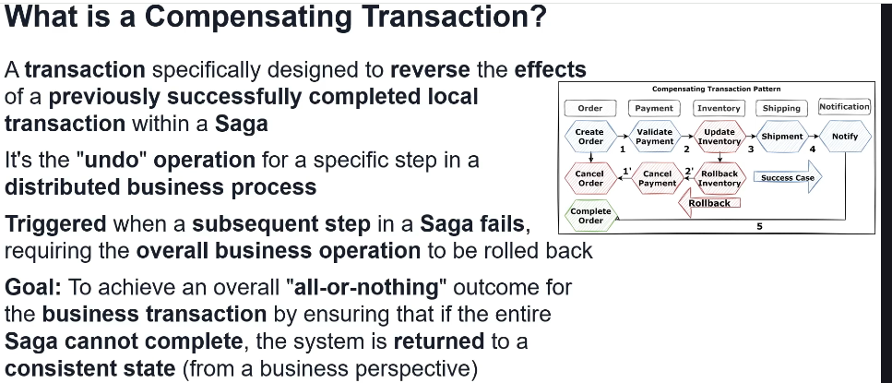

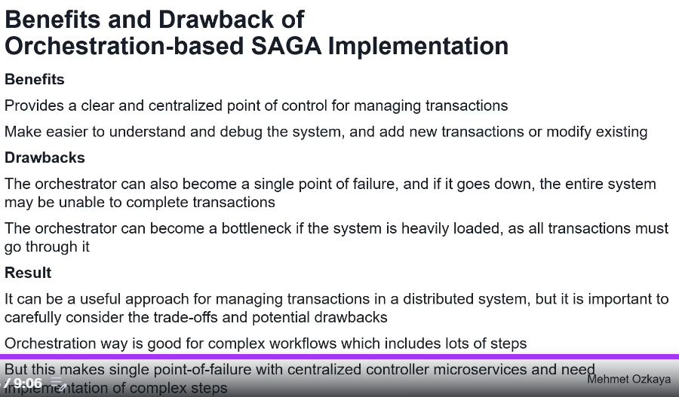

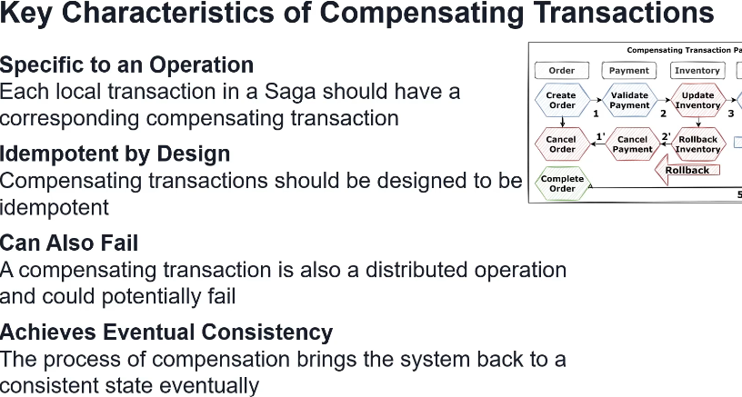

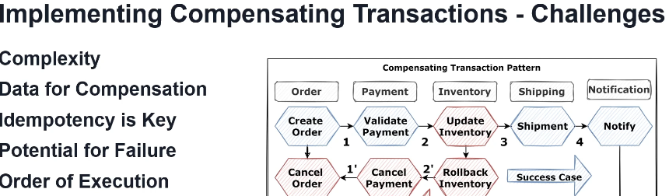

Dual Write problem

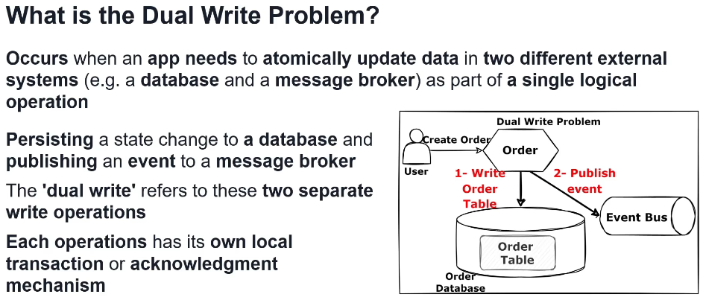

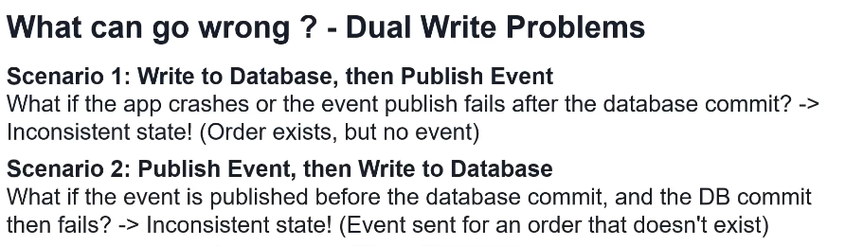

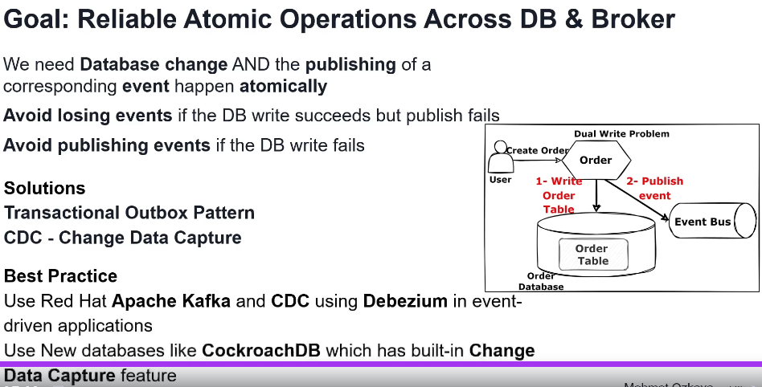 Transactional Outbox pattern

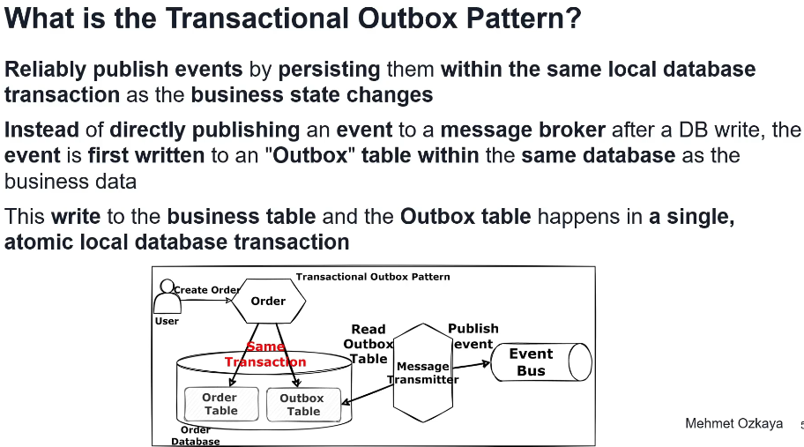

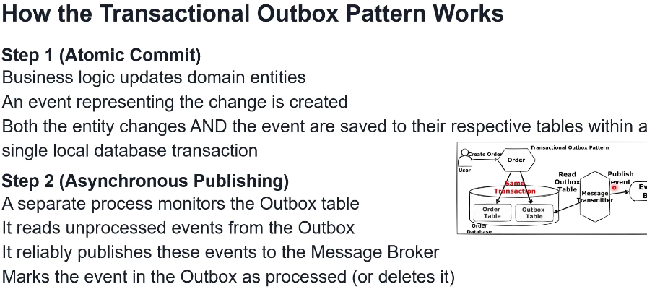

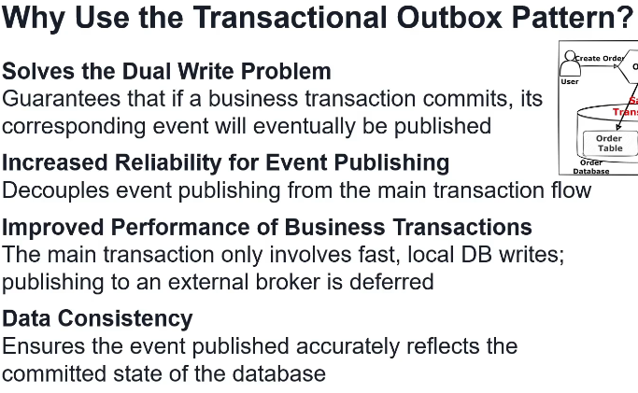

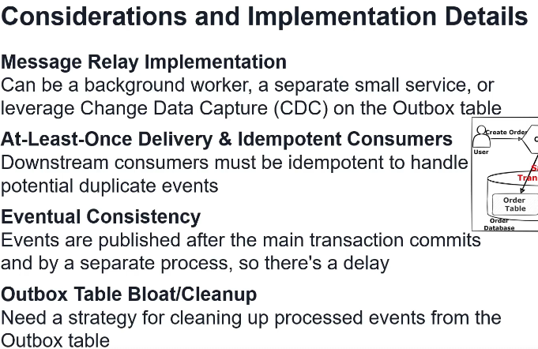

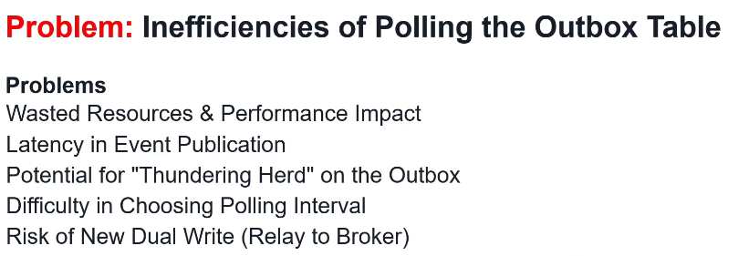

Change Data Capture for Outbox pattern da resi problem

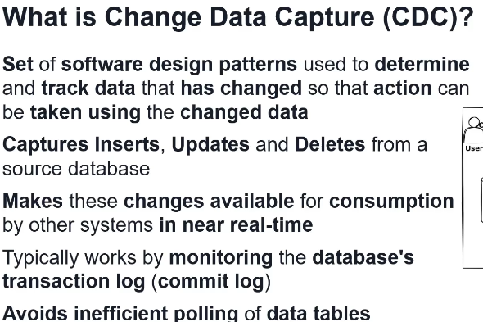

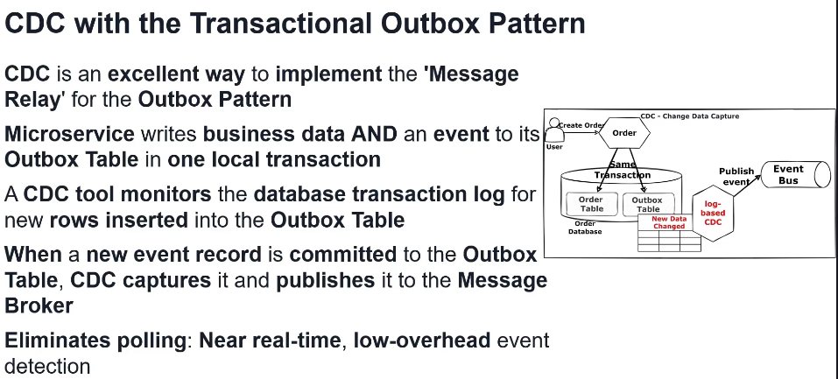

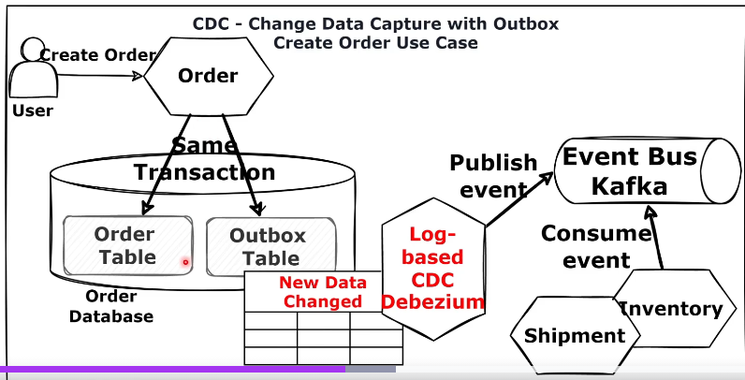

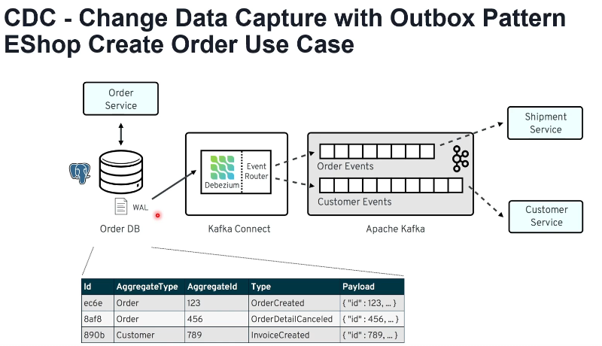

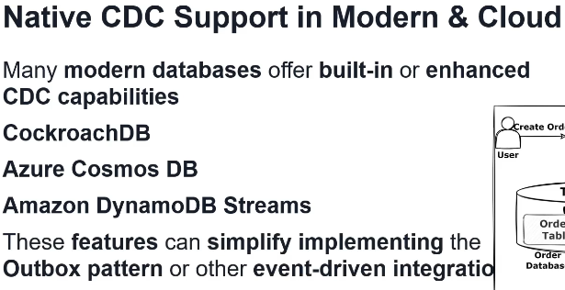

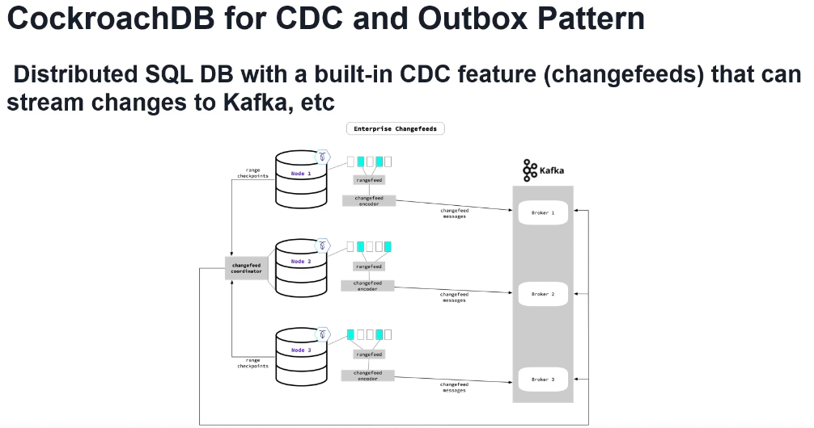

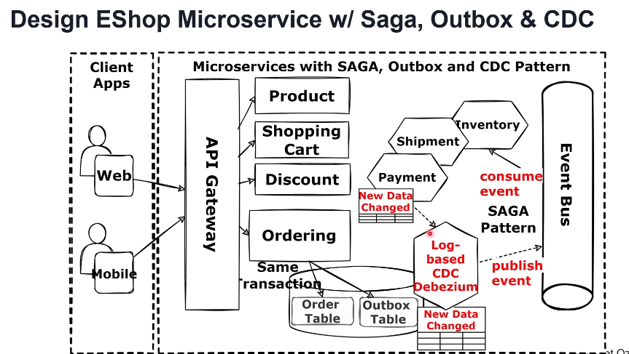

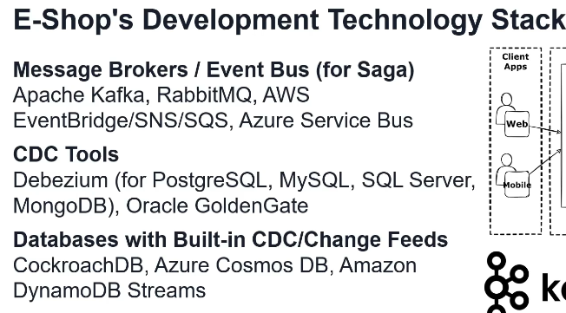

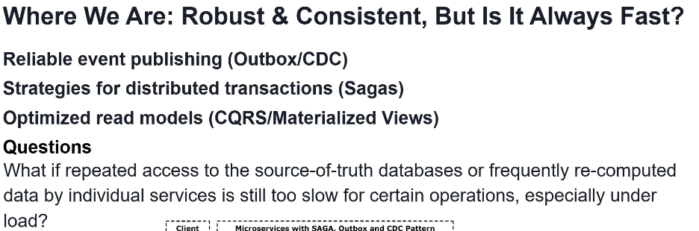

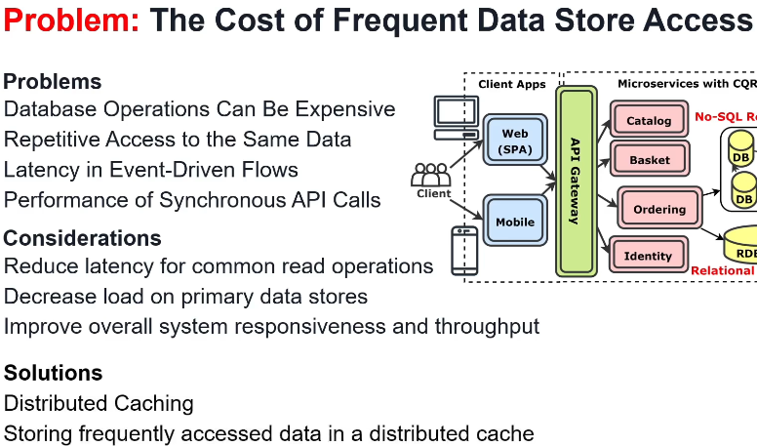

**Microservices data management – distributed caching:**

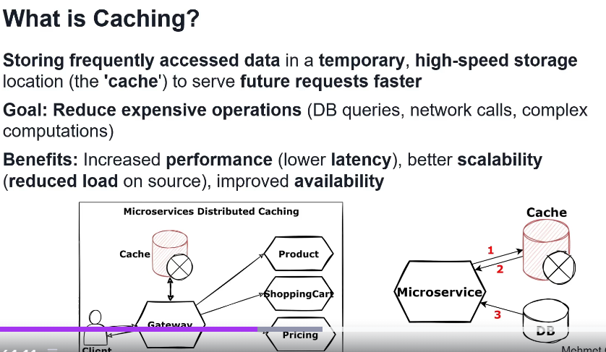

Types of caching

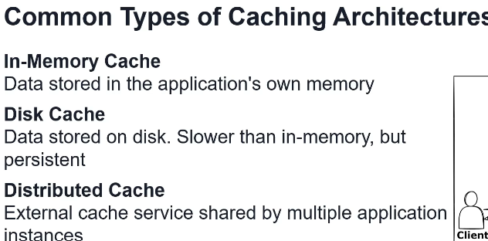

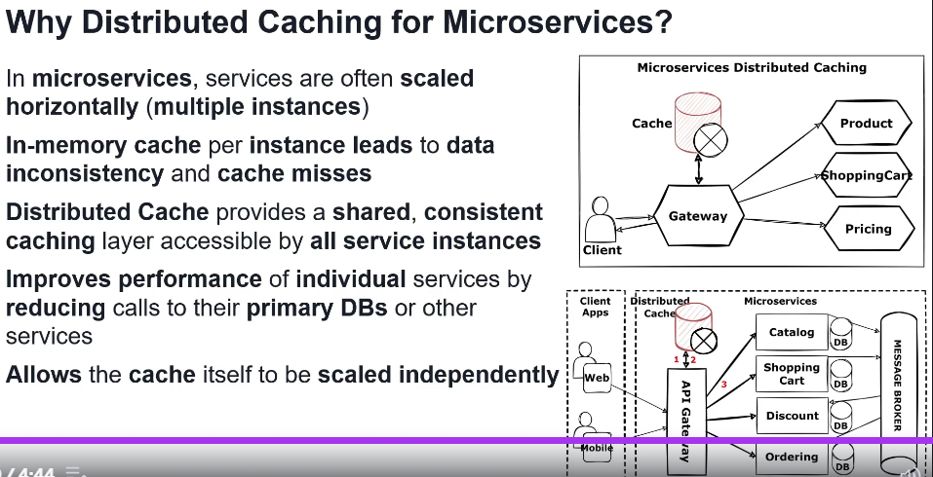

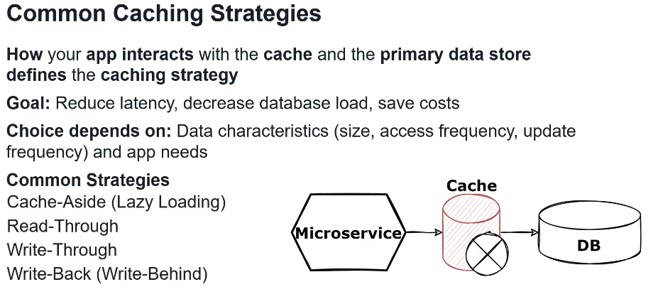

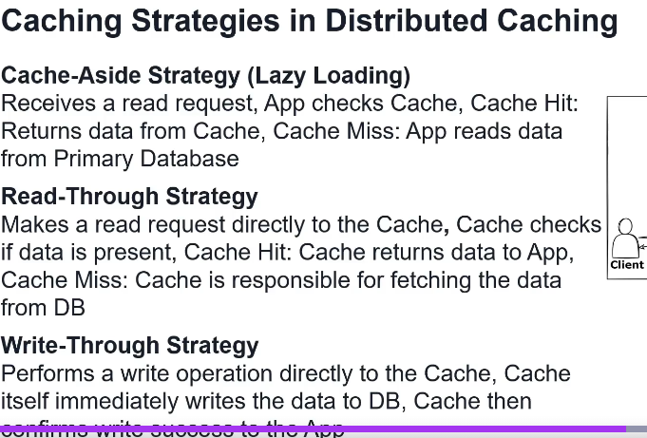

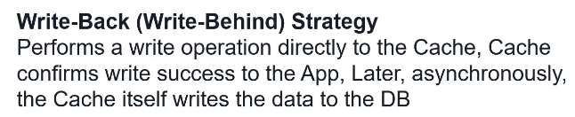

Cache-aside se najcesce koristi

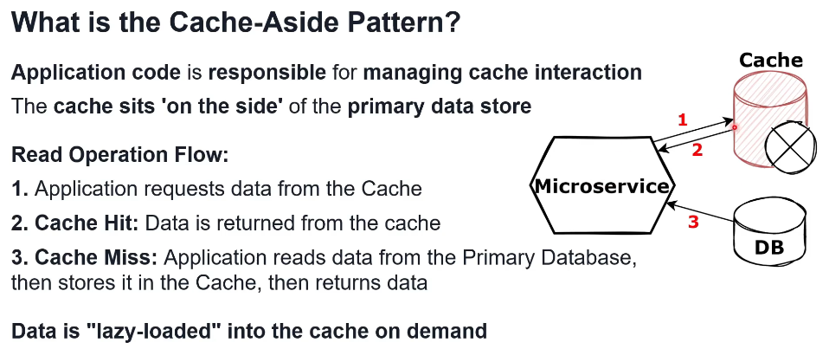

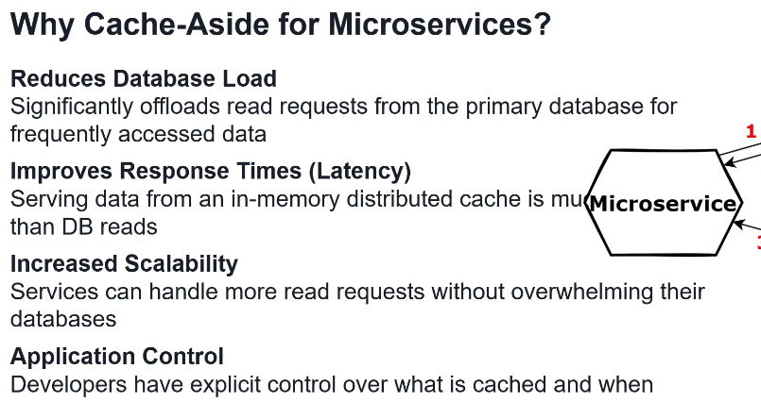

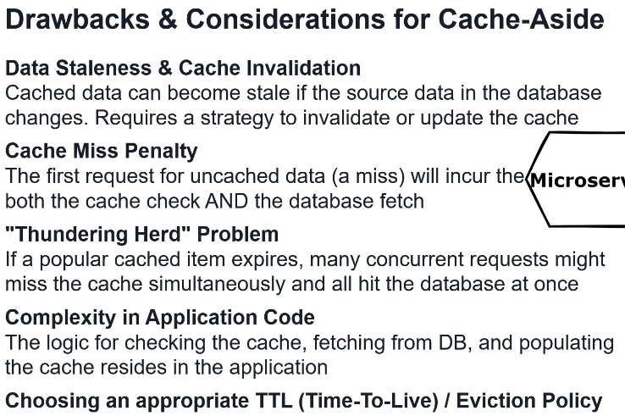

Cache-aside in API Gateway

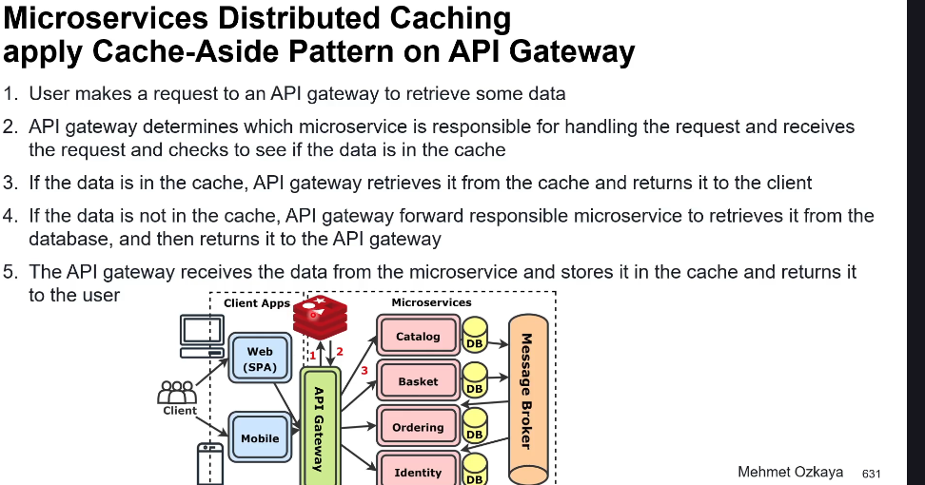

Cache-aside in microservices postoji I msm da se cesce radi nego ovo iznad

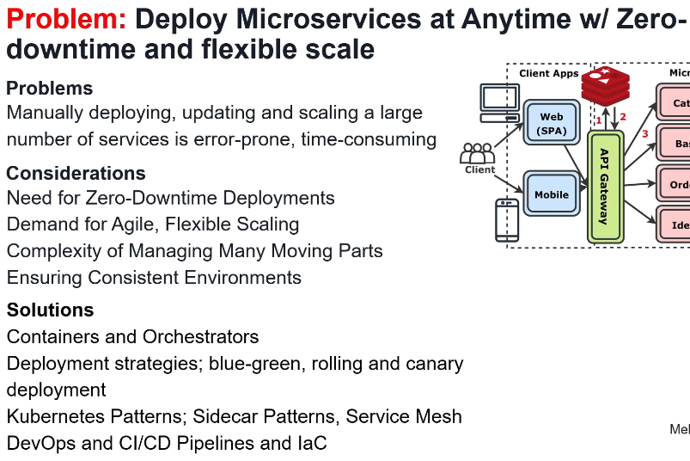

**Microservice deployment with Containers and Orchestrator:**

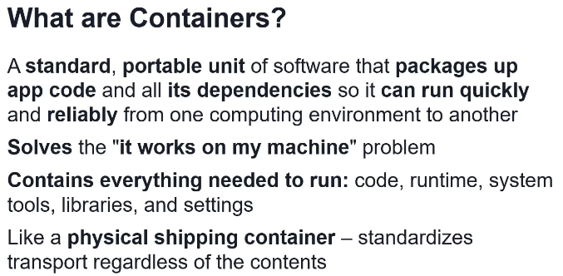

Container vs Virtual Machine

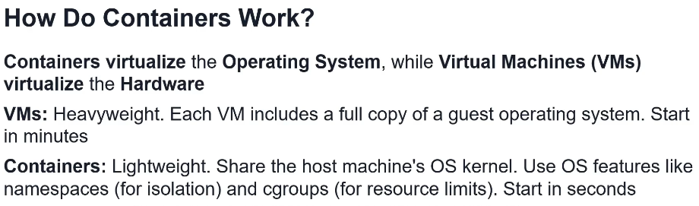

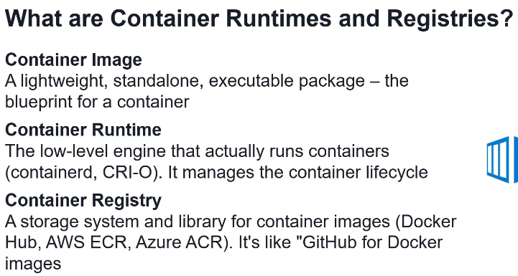

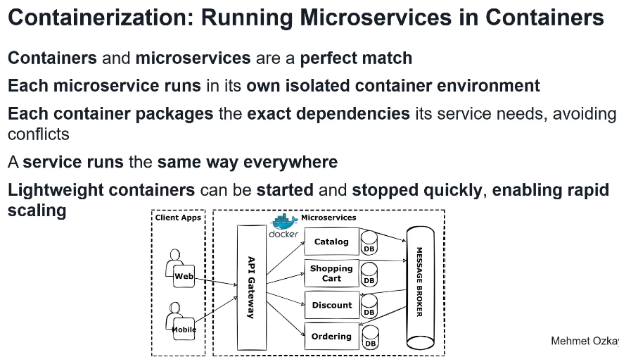

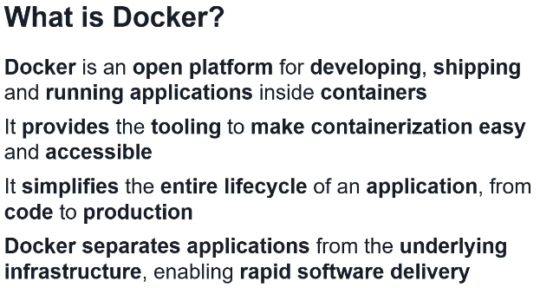

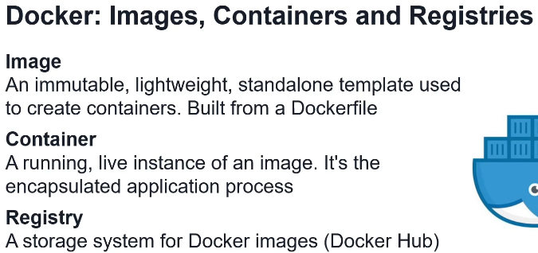

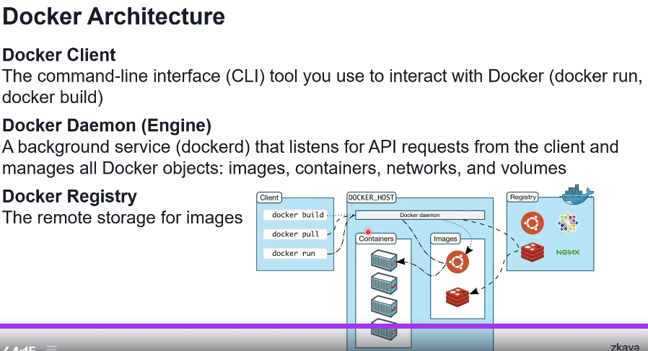

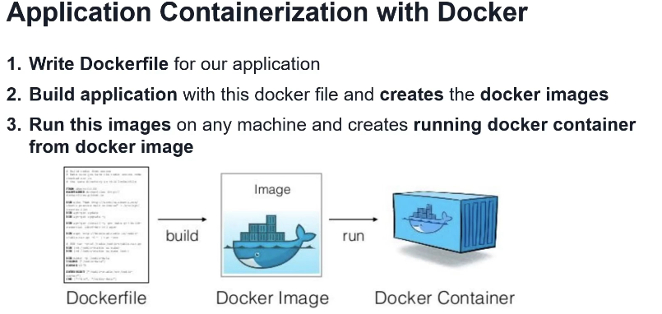

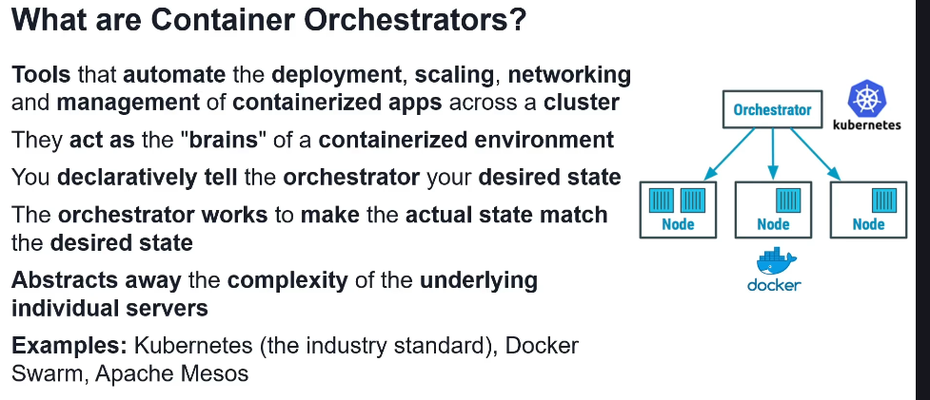

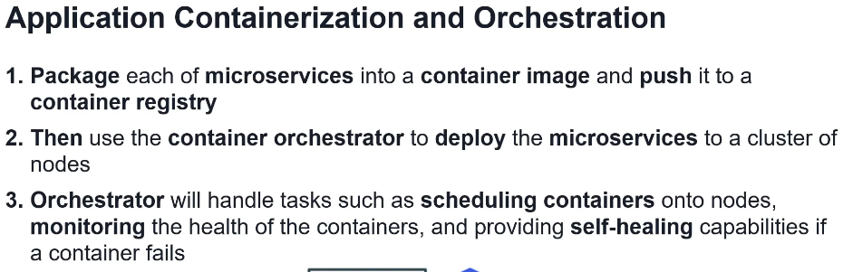

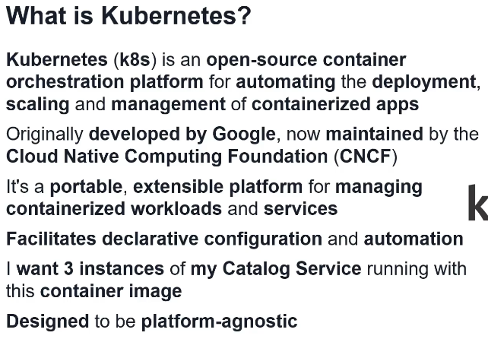

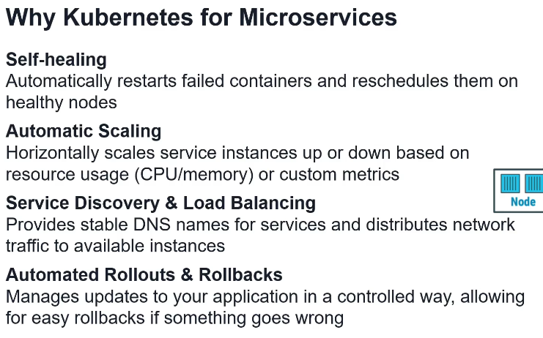

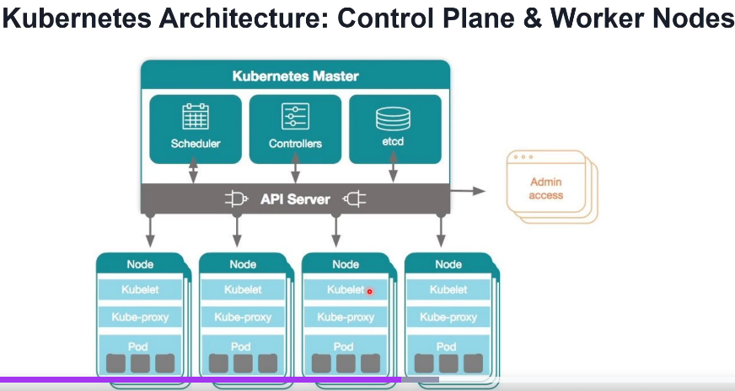

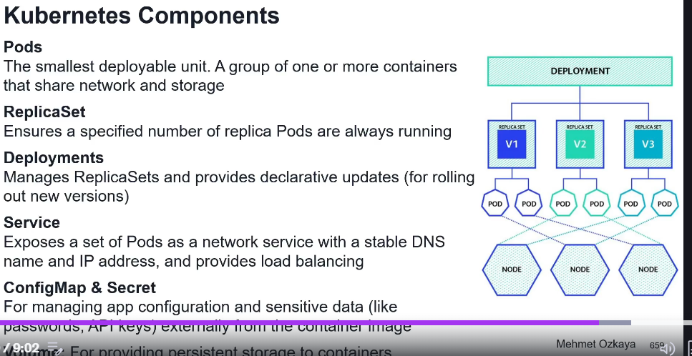

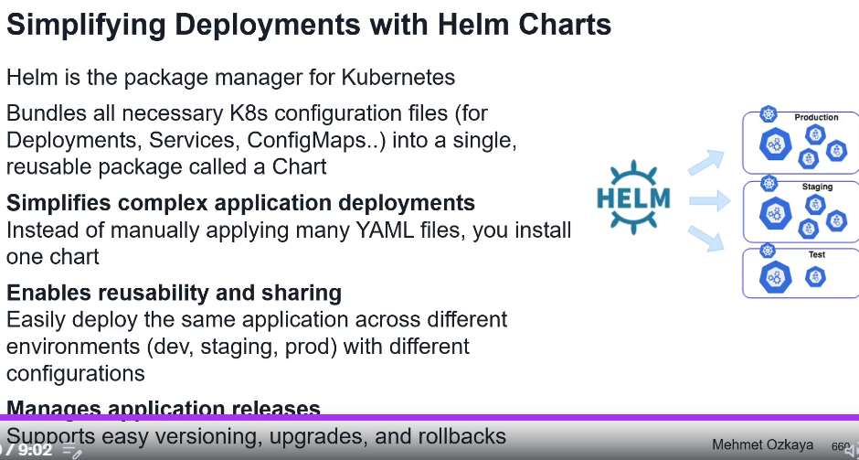

Sidecar and Service mesh patterns

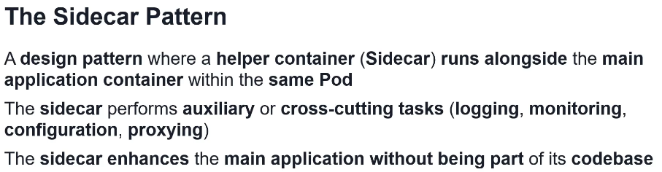

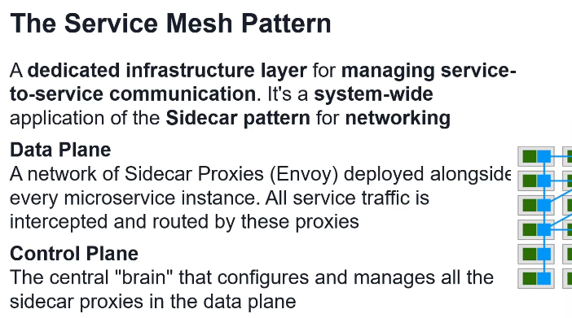

DevOps and CI/CD

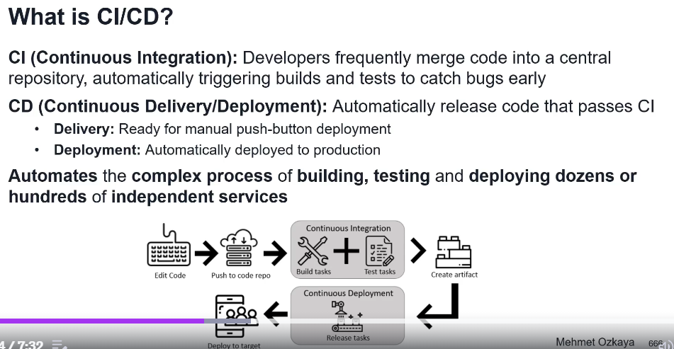

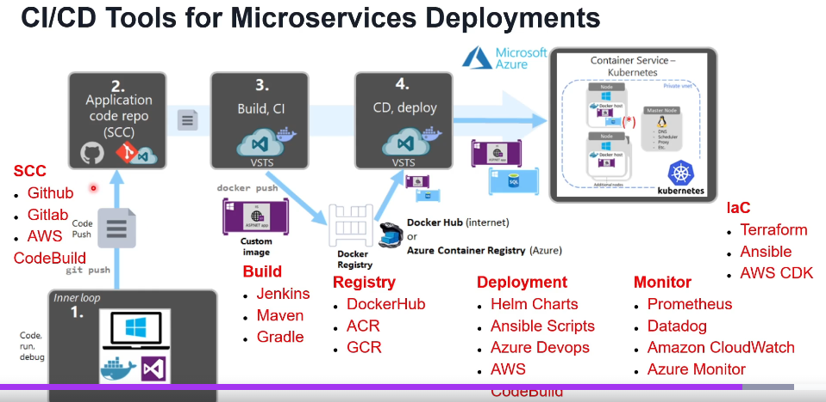

Development strategies: Rolling development, Blue-Green development, Canary development

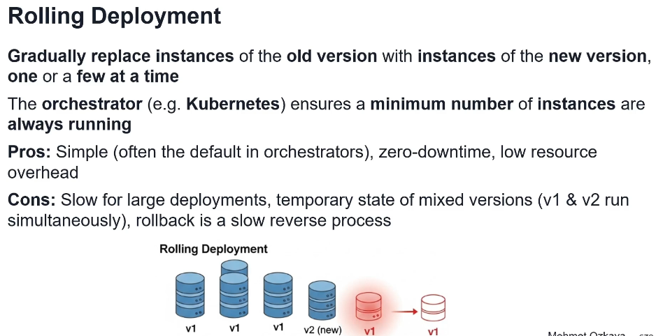

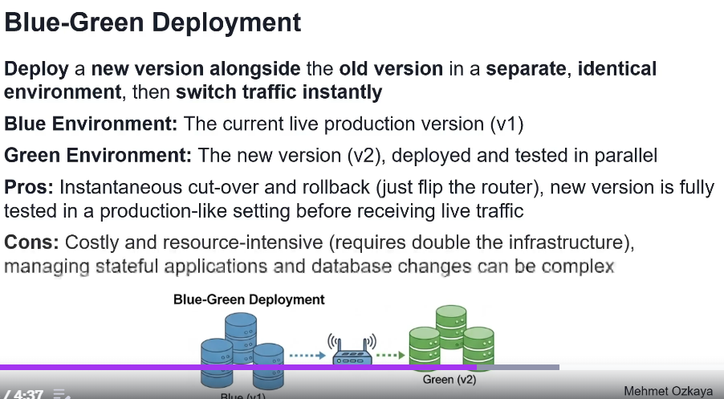

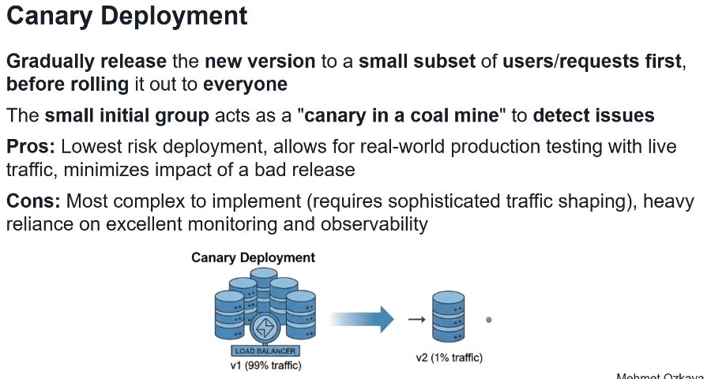

Infrastructure as Code

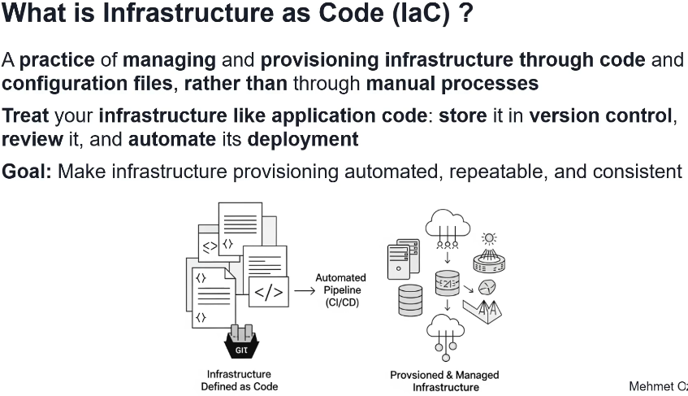

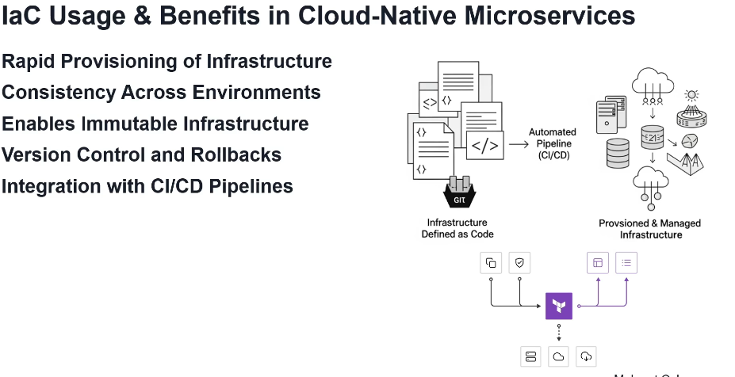

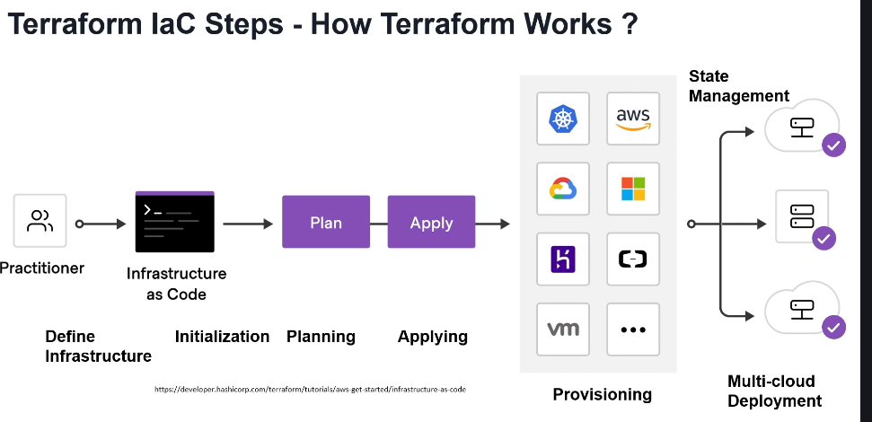

GitOps

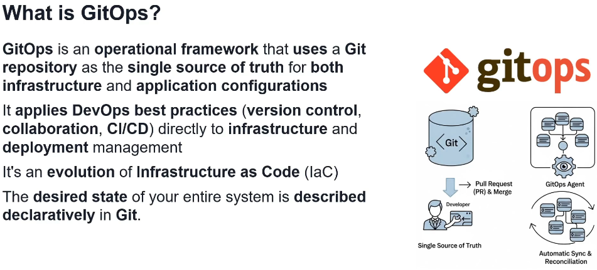

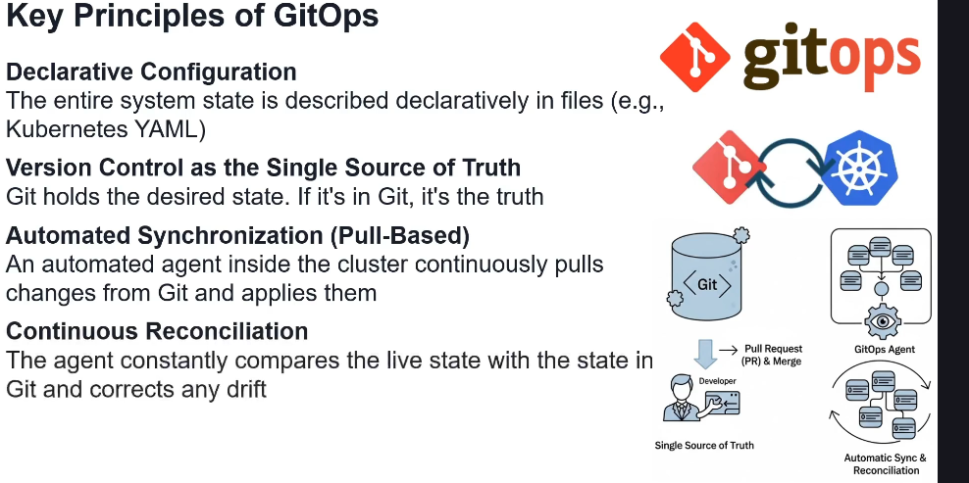

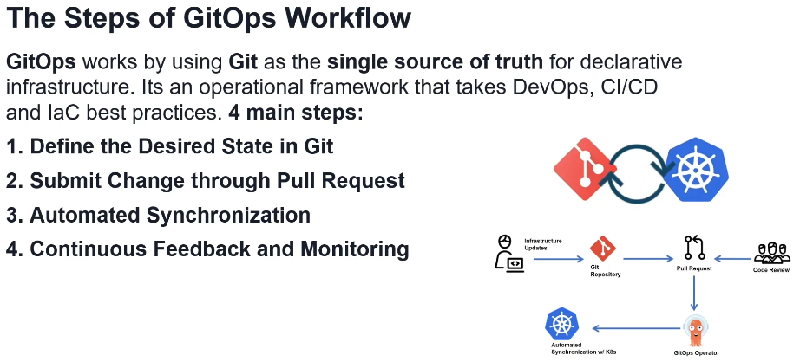

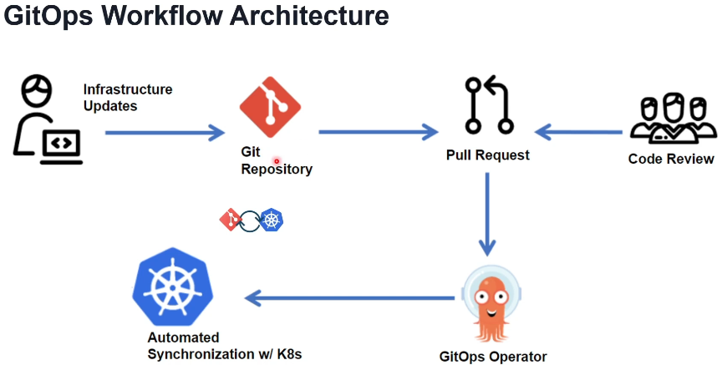

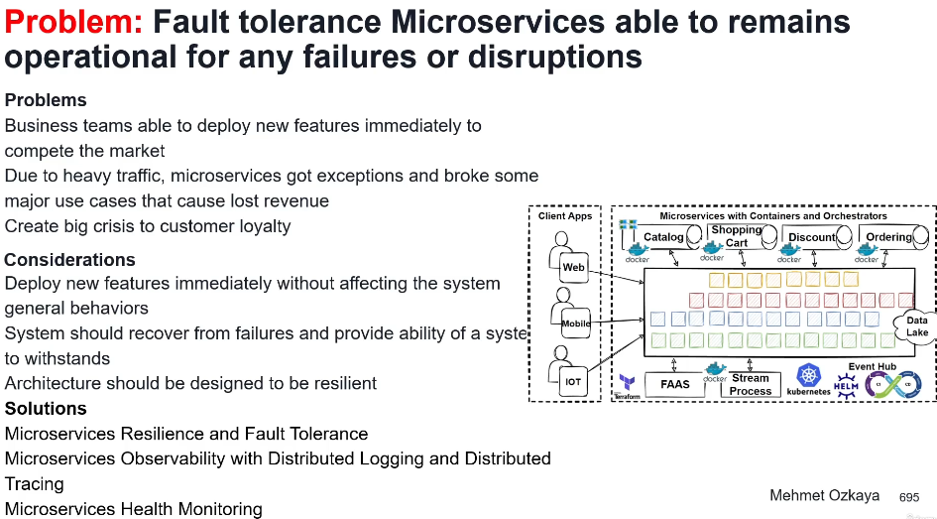

**Microservice Resilience, Observability and Monitoring:**

Microservices Resilience

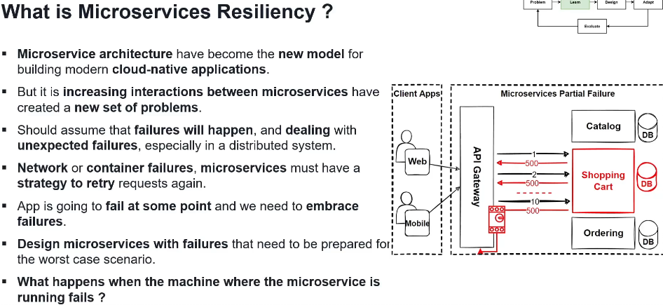

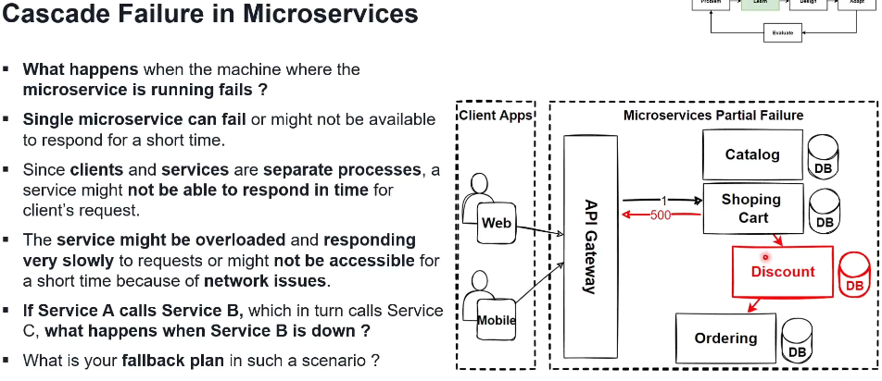

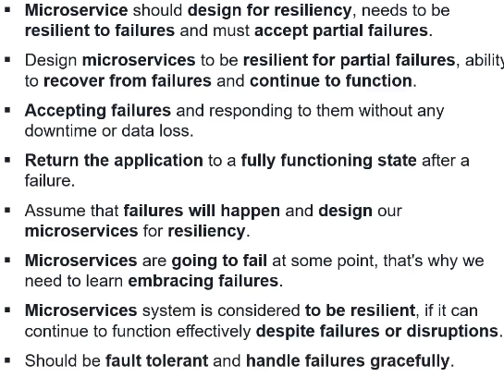

Microservice Resilience patterns

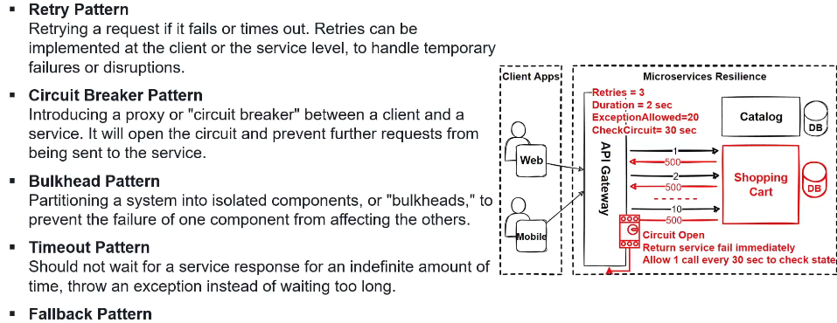

Retry pattern

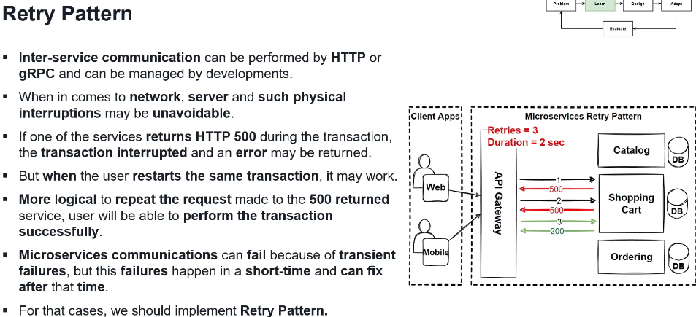

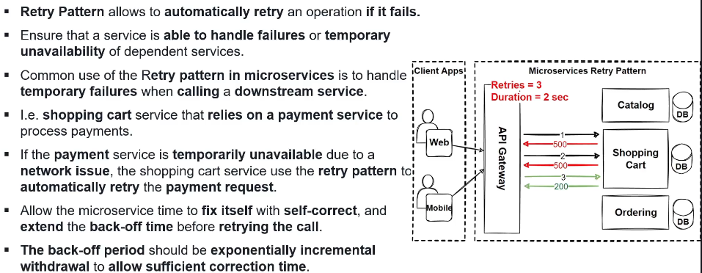

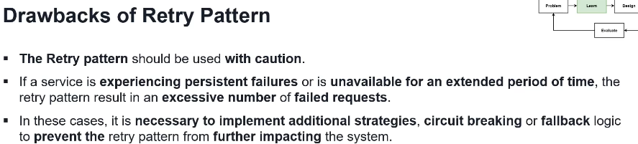

Circuit Braker pattern

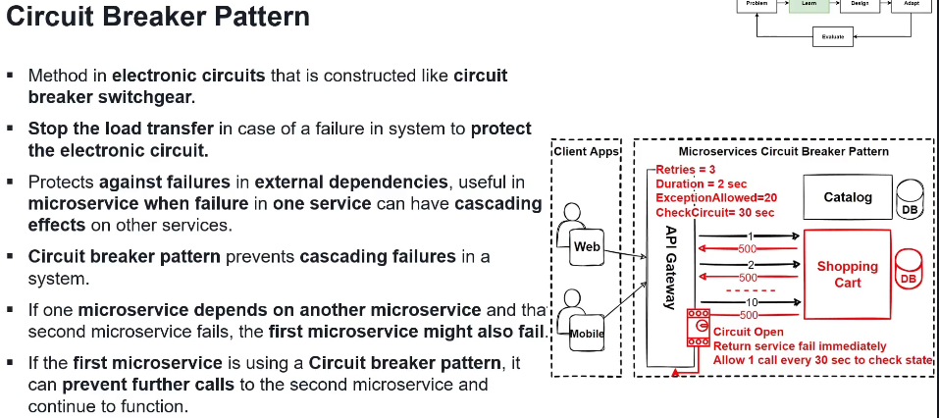

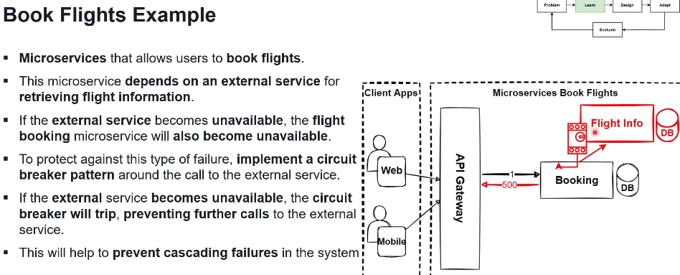

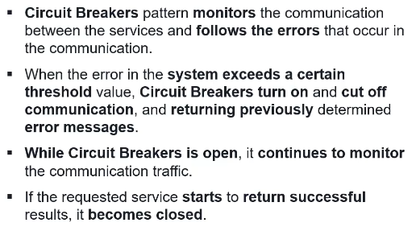

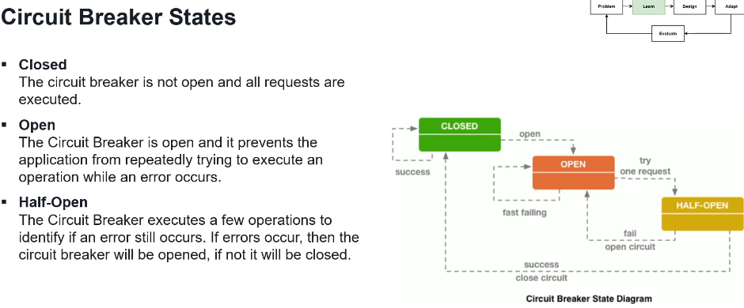

Retry + Circuit Braker pattern se kombinuju cesto

Bulkhead pattern

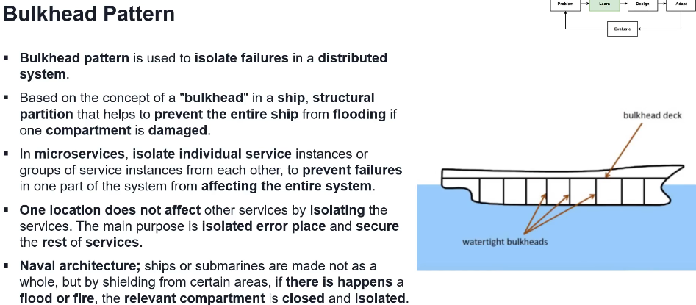

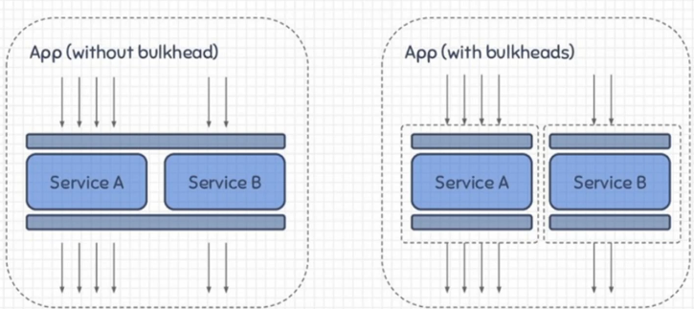

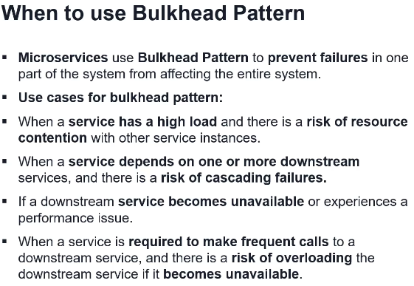

Timeout pattern

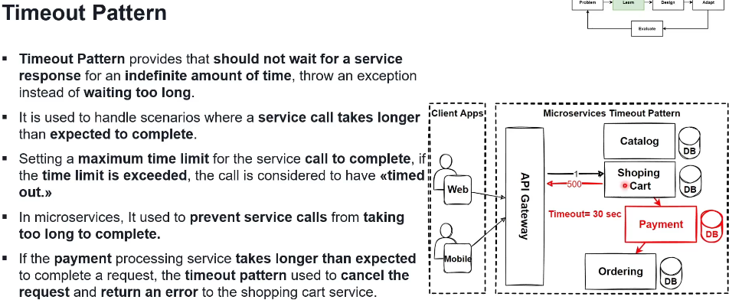

Fallback pattern

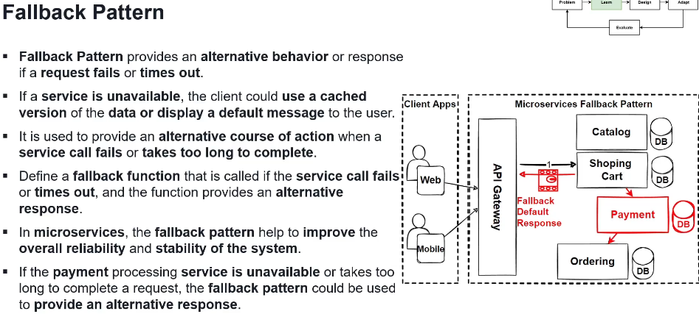

Microservices observability with distributed logging and tracking

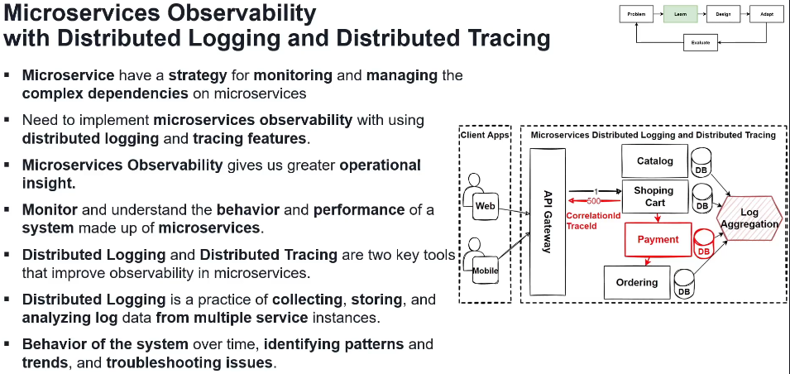

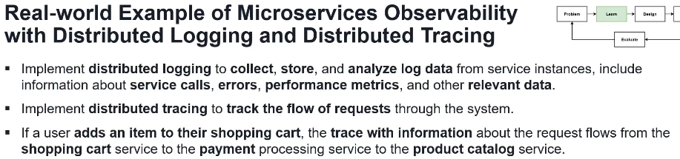

Elastic Stack (Logstash, ElasticSearch, Kibana) for microservices observability with distributed logging

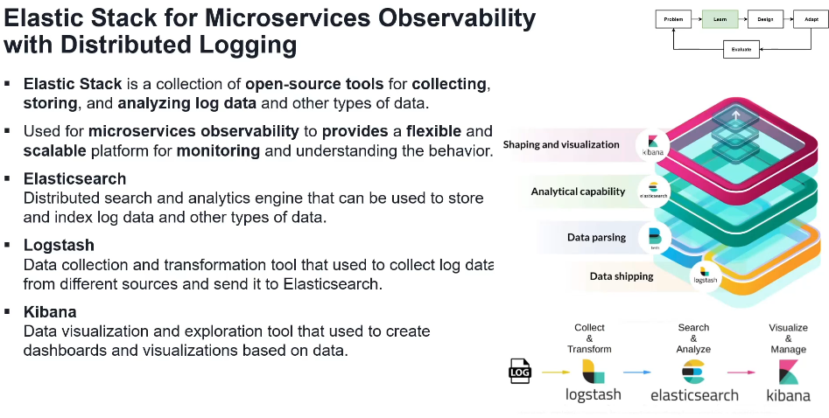

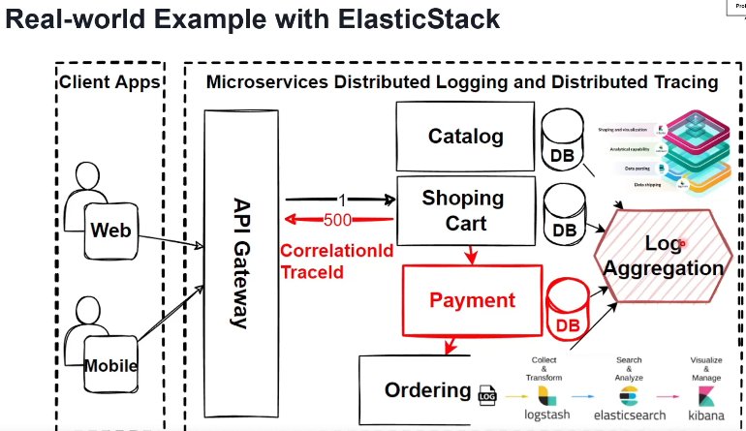

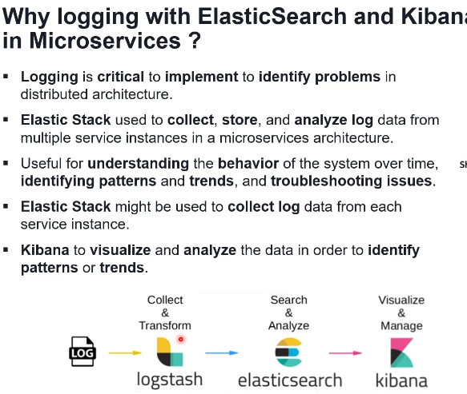

Microservices distributed tracing with OpenTelemetry using Zipkin

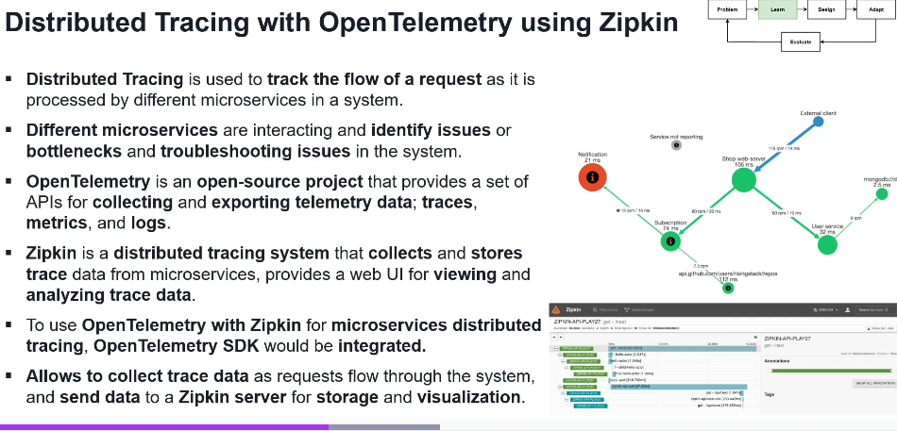

Microservices Health Checks

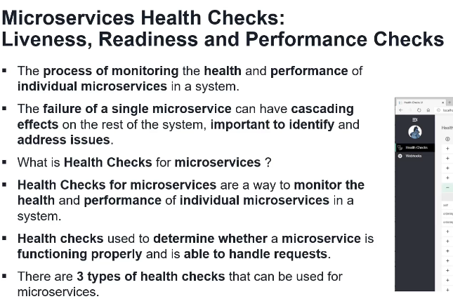

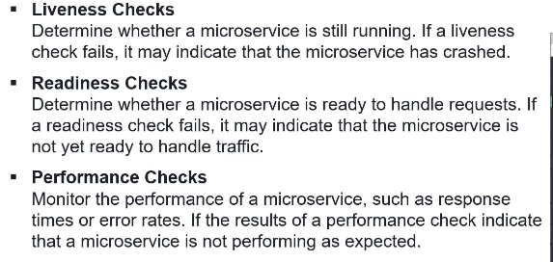

Microservices health monitoring with Kubernetes, Prometheus & Grafana

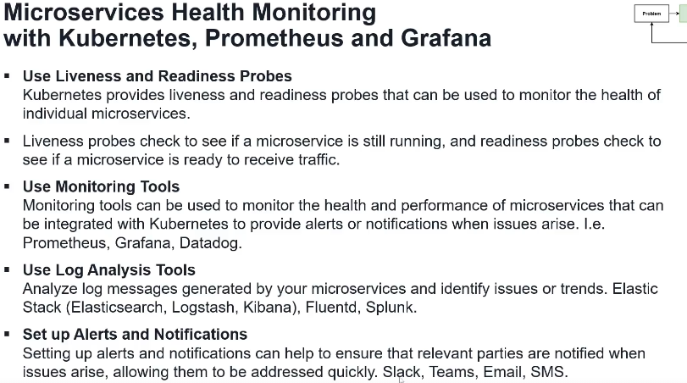

**Serverless Microservices Architecture:**

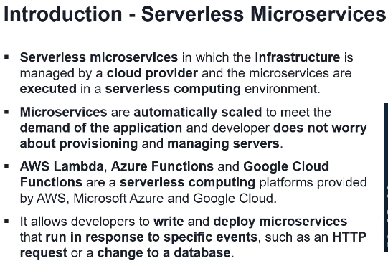

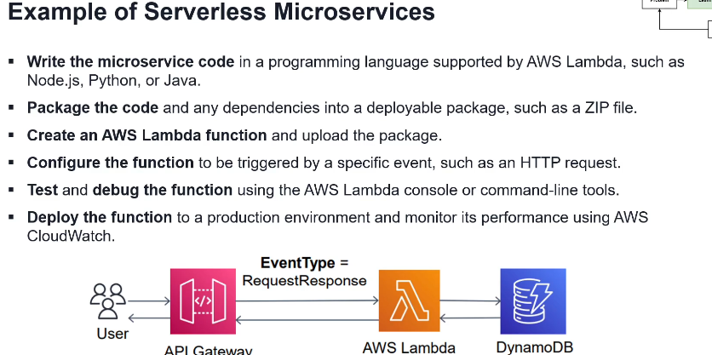

<https://medium.com/aws-serverless-microservices-with-patterns-best/aws-event-driven-serverless-microservices-using-aws-lambda-api-gateway-eventbridge-sqs-dynamodb-a7f46220b738>

<https://medium.com/aws-serverless-microservices-with-patterns-best/using-aws-lambda-as-a-microservice-dd7d7296c74a>

Microservices Cloud-native transform into Serverless

